MD. SAYEM SADIQ
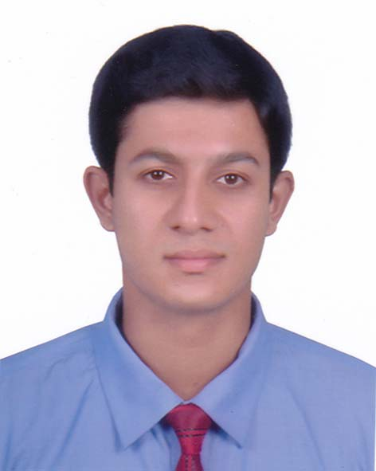

House: 07, Road: 07, Flat: 07, Nikunjo-2, khilkhet, Dhaka

Cell: +8801700676819;

e-mail : sayem.shiam244@gmail.com

Career Objective
I am a self-aware and self-respective person hopping to be a global corporate executive in multinational organizations. I will serve and to develop the career as a business research based personnel in a challenging environment with excellent career development prospect.
Academic Qualification

Degree | Institute | Passing year | Result
Masters of Business Administration (Concentration in HR & Marketing) | American International University-Bangladesh | Ongoing (24 credits completed) | CGPA 3.42 out of 4
Bachelor of Business Administration  (Concentration in Marketing) | American International University-Bangladesh | 2017 | CGPA 3.26 out of 4
Higher Secondary Certificate | Cantonment Public School & College, Rangpur | 2012 | CGPA:4.30 out of 5
Secondary School Certificate | Cantonment Public School & College, Rangpur | 2010 | CGPA:4.19 out of 5

Professional Experiences

Designation: Executive (Marketing) Designation: Internship
Organization: Festivity events Organization: EXIM BANK LTD.
Duration: From 13th October – 27th November, 2017 Duration: 2th May-24th july 2017
(General Banking and Customer Service)
Trainings and Workshops

- Project Management By PMI Bangladesh Chapter
27th May 2016 at University of Dhaka
- Supply Chain Management By Bangladesh Apparel Professional Society
23th December 2016 at Hotel Orchard Suites
- Social Enterprise at the Social Business Expose program
11th-12th March at Daffodil International University
- Career@MNC By Circle Foundation
25th March 2016 at world literature center
Corporate Trainings

- Excellence In Corporate Sales Management
- Mr. Taslimur Rahman, Head Of Corporate Business, Transcom Digital at bdjob.com training
- Tips and Techniques For Building Strong and Lasting Client Relationship

- Ms. Nahreen Chowdhury, Relationship Manager, Standard Chartered Bank at AIUB

Extra-Curricular Activities

- Volunteer Member at SHOUHARDA -YOUTH F OUNDATION (a social organization)
Language proficiency

- High proficiency in English & Bengali Speaking, Reading, Writing
Educational Tour

- Akij Food and Beverage Limited (AFBL) at Dhamrai, Dhaka
- Kazi & Kazi Tea Estate Ltd. at Panchaghar
- Maddhapara Granite Mining Company Limited (MGMCL) at Dinajpur
Computer skills

- Ms word, MS excel, MS power point, Internet Communication
Interest

- Socializing, Idea generating, Reading newspapers, Playing cricket, Travelling at historical places
Interpersonal skills

- Friendly, Helpful, Cooperative, Grateful, Able to work under pressure & Team work
Personal details

Father’s Name: MD. AHKAM HABIB CHOWDURY

Mother’s Name: MRS. AFROZA BEGUM

Date of Bi:rth: March 19, 1995

Marital Status: Unmarried

Permanent Address: House no: 66, Road no: 2 (PTI), Kotkipara, Dhap, Rangpur

References

Name : Barrister Junayed Mohammed Name : MD. Rasfeq Hossain
Organization : Stamford University Bangladesh, AIUB Organization : Nitol Motors Ltd. Designation : senior lecturer, Adjunct faculty Mohakhali, Dhaka Phone : 01785873360 Designation : Sr. Manager e-mail : Junayed.allbar@gmail.com Phone : +8801919090240
e-mail : rusho_mce@yahoo.com

