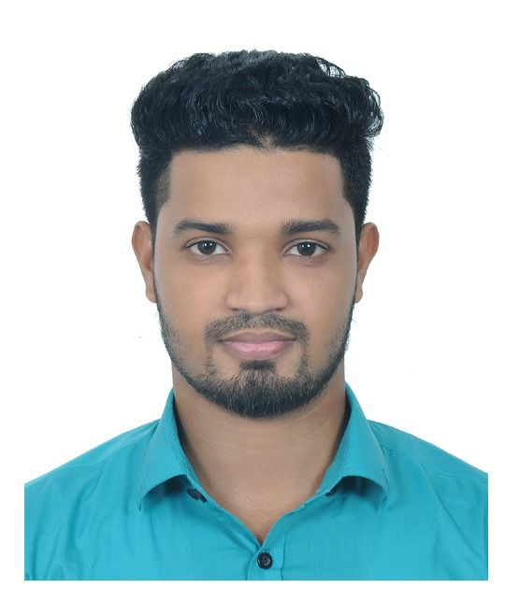
RESUME OF
MD SHAHAB UDDIN
Address: Al-Marzan market, flat no:A-6,zindabazar,sylhet.
Mobile No : 01749012110
e-mail : imshahab40@gmail.com

Career Objective:
I am hardworking, energetic and self-motivated person. Seeking to perform in a challenging environment where creative talent, conceptual ability, leadership, communication and innovative capabilities can be efficiently utilized and would help me to explore my expertise. I step forward to accept the responsibilities, handle problematic situation with confidence and a proven team.

Employment History:
Total Year of Experience : 0.3 Year(s)
1. | Engineer Trainee ( February 9, 2018 - May 5, 2018)
Zamil New Delhi Infrastructure Private Limited
Company Location: Moulvibazar branch office, Sylhet.
Department: Maintenance and service.
Duties/Responsibilities:
To observe all security system including key alarms under Banglalink networking tower to provide flawless network service to their registered subscribers and customers. Providing on call duty to active all associate member and look forward to different tower site.

Academic Qualification:
Exam Title | Concentration/Major | Institute | Result | Pas.Year | Duration | Achievement
Bachelor of Science (BSc) | Electrical & Electronic Engineering | Metropolitan University, Sylhet | pass | 2017 | 4 years | CGPA : 3.61
HSC | Science | Sylhet Govt College | pass | 2012 | 2 years | 5.00
SSC | Science | Jagdal Al-Faruk High School | pass | 2010 | 2 years | 4.94

Training Summary:
Training Title | Topic | Institute | Country | Location | Year | Duration
Industrial training in power plant. | electrical transmission,distribution system and power system protection activities. | Power Grid Company of Banladesh Limited | Bangladesh | sylhet | 2016 | 1 month

Specialization:
Fields of Specialization
- MS Word/ Excel/ PowerPoint
- Computer operating
- call service provider

Extra Curricular Activities:
- volunteer worker under Rotaract club of Sylhet surma valley,RID-3282 Bangladesh.
- Rober scout member of Metropolitan University,Sylhet.
- Member of Muhona cultural organizasiton ,MC College,Sylhet.

Language Proficiency:
Language | Reading | Writing | Speaking
Bangla | High | High | High
English | High | Medium | High

- IELTS OVERALL BAND SCORE 6.

Personal Details :
Father's Name | : | Md Turan Rashid
Mother's Name | : | Asma Begum
Date of Birth | : | June 5, 1994
Gender | : | Male
Marital Status | : | Unmarried
Nationality | : | Bangladeshi
National Id No. | : | 19949012938000019
Religion | : | Islam
Permanent Address | : | Jagdal, Jagdal, Derai, Sunamganj.
Current Location | : | Sylhet

Reference (s):
Name | : | Surajit Sinha
Organization | : | Metropolitan University,sylhet
Designation | : | Assistant Professor
E-Mail | : | s.sinha@metrouni.edu.bd
Relation | : | Academic

I hereby declare that the above statements are correct and complete to the best of my knowledge.

