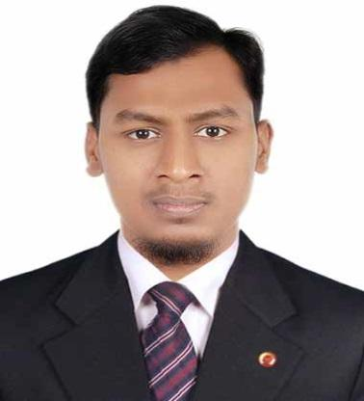
Resume of
Md Taijul Islam
Bagdi,Ghorashal,Palash,Narsingdi,Dhaka

E-mail: taijul49@yahoo.com. Phone: 01775-123813

Career Objective:

To build up myself as a professional through serving as a personnel at any reputable organization with outmost sincerity and step ahead to be a successful employee in life through achieving organization all goal.
Job Profile:

Having the training academically as well as professionally to manage entire production and maintenance related problem as well as excellent interpersonal skills and ability to motivate staff to achieve shove goal.
Education:

B.Sc.in EEE- Bachelor of Science in electrical and electronic engineering
Institution : BUBT- Bangladesh University of Business & Technology.
Session : 2018
GPA : 2.68out of 4.00
Major : EEE (Telecommunication)

Diploma
Institution : Dhaka polytechnic institute.
Session : 2011
GPA : 2.89 out of 4.00
Group : Computer technology.

S.S.C- Secondary School Certificate from Dhaka Board.
Institution : Pubali Jute Mills High School
Session : 2007
GPA : 4.38out of 5.00
Group : Science
Experience:

ARRIVAL FASHION LTD.
- IT Officer - 1th November 2019 to till now.
Responsibilities:

- Repair, Install & Configure laptop, printer, mobile, scanner, other devices.
- Configure Mikrotik router, multi vendor router, network switches.
- Maintain data backup and configure email.
- Troubleshoot software and hardware problem of computer users.
- CC camera installation and maintenance.

GHORASHAL CONTAINERS LTD.
- Engineer - 1th September 2013 to 20th October 2019.
Responsibilities:

- Monitoring production manpower & machine.
- Prepare production machine statue & maintenance document.
- Check production target if not achieve take action.
- Machine troubleshooting.
- Compressor chiller maintenance.
- Preparing daily weekly machine chiller compressor report.

THAKRAL INFORMATION SYSTEM
- Sub assistant engineer: April 2012 to may 21th may 2012.
Responsibilities:
- Repairing of power supply, monitor ,
- Repairing UPS, printer.
- IBM desktop problem, flash update ,pc doctor,
- Server set up.
- Fundamental of network.
Extra Curriculum:

- I can do house wiring.
- I can operate and maintenance blow molding machine.
- I have experience controlling big production plan.
- Member of the champion team in inter department all cricket competition in bubt.

Skill:

Language Skill:
- Very good knowledge on reading, writing as well as speaking fluently in English.
- Very good knowledge on speaking Hindi.
- I'm a good problem solver. I quickly find a problem and fix it quickly.

Computer Skill:
- Operating System: Windows-98/2000/XP/Vista/Seven.
- Application Packages: MS Word, Excel, PowerPoint.
- Web Application: E-mail, Internet

Personal Details:
Name : Md.Taijul Islam
Father’s Name : Md Kamal Uddin
Mother’s Name : Sayma Akter
Date of Birth : 02_01_1992
Height : 5’6”
Blood Group : B+ (ve)
Nationality : Bangladeshi
Religion : Islam
Sex : Male
Marital Status : Married
Reference By:

Md. Sohel Rana  Assistant Professor CSE  Bangladesh university of business and technology (BUBT)  Cell: +8801785699130  Mail: sohelresearch@gmail.com | Md. Mostafijur Rahman  Assistant Professor ICT  BOF, Gazipur,Dhaka.  Cell: +8801738440406  Mail: mostafijur.csc@hotmail.com

I am Md Taijul Islam, certify that all the information provided here is authentic.

With Respectfully


…………………..
Md Taijul Islam

