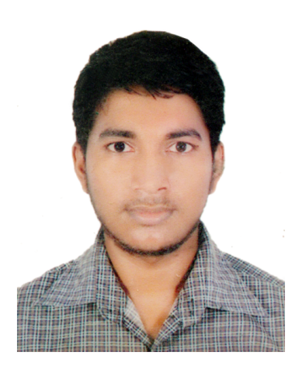
Resume

Of
Md. Alam Hossain
E-mail:alamhs30@gmail.com

Mailing Address:
11, Nurerchala Bazar, West Batara,
Dhaka, 1212
Cell: +8801833-713242

CAREER OBJECTIVES

Looking For Better Opportunity In A Suitable Position, Where I Can Utilize My Knowledge And Creativity Gained From My Education And Job Experience.

Education Background

Bachelor of Business Administration (B.B.A)
Institute Name : Habibullah Bahar University & College
Major : Marketing
Passing Year : Running (4th year)

Higher Secondary Certificate (H.S.C)
Institute Name : Dhaka Imperial College
Group : Business Studies
Result : 5.00 (Out of 5.00)
Board : Dhaka
Passing Year : 2014

Secondary School Certificate (S.S.C)
Institute Name : Chandanpur M.A High School
Group : Business Studies
Result : 4.44 (Out of 5.00)
Board : Comilla
Passing Year : 2012

Experience & Training

- Name of Company : Pran RFL Group
Designation : Sales Executive
Duration : 19/04/2017 to till now.

- Name of Company : Sholpik
Designation : Sales Executive
Duration : 01 year

COMPUTER LITERACY

• Microsoft Office (MS word, Power Point, Excel and Access)

FIELDS OF INTEREST

- Interested To Creative Thinking, Traveling, Sports, Hard Working, Cultural And Social Working.

COMMUNICATION SKILL

- Considerably Very Good In Reading, Writing And Spoken In Both Bengali And English.

PERSONAL DETAILS

- Name : Md. Alam Hoshen
- Father’s Name : Ramiz Uddin
- Mother’s Name : Rushia Begum
- Date of Birth : 2 March,1996
- Nationality : Bangladeshi (By Birth)
- Home District : Comilla
- Religion : Islam
- Marital Status : Unmarried
- Height : 5'-10"

Signature:

Date:

