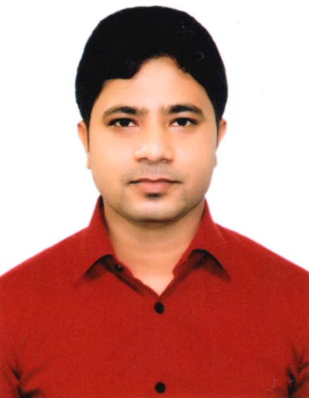CURRICULUM VITAE
Md. Asaduzzaman
Hafiza Lodge (3rd Floor)
Unit-402, P.O: Chawkbazar,
Mohammadpur, Muradpur,
Panchlaish, Chittagong.
Mobile: 01829576961
Email: sujona802@gmail.com

CAREER OBJECTIVE | To Gain utmost competence through enthusiasm, hard work, ethics, sincerity, and brilliance. Moreover, serve for the welfare to society and the economy though the assigned responsibility.
SCHOLAR RECORDS | Masters of Arts (M.A)  Subject  Institution  University  Year of Passing  Result | : Islamic History & Culture  : Govt. City College  : National University  : 2015  : 2nd Class
SCHOLAR RECORDS | Bachelor of Arts (B.A) Pass  Subject  Institution  University  Year of Passing  Result | : Social Science  : Chittagong College  : National University  : 2011  : 2nd Class
SCHOLAR RECORDS | Higher Secondary Certificate  Group  College  Board  Year  GPA | : Humanities  : Chittagong College  : Chittagong Board  : 2006  : 3.10
SCHOLAR RECORDS | Secondary School Certificate  Group  College  Board  Year  GPA | : Science  : Kanchanagar High School  : Chittagong Board  : 1999  : 1st Division
EXPERIENCE | 1.Position: Executive (Planning)  Organization: Selim & Brothers Ltd.  Address: BSCIC Industrial Area, Sagorika, Ctg  Duration: 01/06/2015 to 30/10/2017  2.Position: Production Officer  Organization: KDS Group  Address: 255 Nasirabad, Ctg  Duration: 21/12/2017 to। 31/05/2018  3.Position : Sales and marketing executive  Organization : S&S group of companies (Travel agent)  Adress : 96 Muradpur, Panchlaish, Ctg.  Duration : 01/06/2018 to till now

SPECIAL  SKILL | - Creating a Comfortable Learning Environment  - Time Management  - Provide Student Support Services  - Relationship Building

LANGUAGE PROFICIENCY | Language Writing Reading Speaking  Bengali Excellent Excellent Excellent  English Good Good Good
COMPUTER LITERACY | Being conversant in several computer languages such as MS-Word, MS-Excel, Power Point etc.
PERSONAL INFORMATION | Full Name : Md. Ausaduzzaman  Father's Name. : Md. Shah Alam Sikder  Mother's Name : Khorsheda Begum  Date of Birth : 1st November, 1983  Sex : Male  Religion : Islam  Marital Status : Married  Nationality : Bangladeshi (By Birth)
PERMANENT ADDRESS | C/O: Md. Shah Alam Sikder, Sikder Bari,  Vill: Kanchannagar, P.O: Khanchanpur,  P.S: Fatickchari, Dist: Chittagong.
PRESENT ADDRESS | Hafiza Lodge (3rd Floor)  Unit-402, P.O: Chawkbazar, Mohammadpur,  Muradpur, Panchlaish, Chittagong.
REFERENCE | Md. Shaiduzzaman  Commercial Executive  Selim & Brothers  Cell: 01811-170163

DECLARATION | I assure that the information furnished above is true and correct to the best of my knowledge and belief.

Sincerely Yours,

________________
Md. Asaduzzaman
Date:

