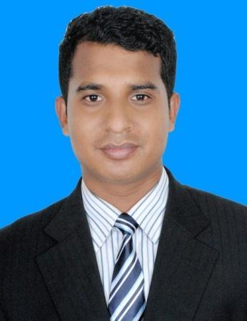
Resume of
MD. HARUN- OR -RASHID
Mobile: 01719840801:
Email: rashid.eeelu@gmail.com
Address : House # 09 (Ground Flour),Rd. # 16, DIT Project
Merul Badda, Dhaka-1212.

Career Objective:

Intend to work in a challenging and competitive environment where responsibility and commitment is required. I would like to develop my career in a reputed organization with
competitive challenging environment, where outstanding performance is to be the success.

Educational Background:

- B.Sc Honors in EEE
Institution: Leading University, Sylhet
Result: 2.5 out of 4.00
Session: 2010-2011
Passing Year: 2015

- Higher Secondary Certificate(Vocational)
Institution: Sylhet Technical School and College, Sylhet.
Result: 3.72 out of 5.00
Group: Technical
Year of Passing: 2010

- Secondary School Certificate(Vocational)
Institution: Sunamgonj Technical School and College, Sylhet
Result: 3.23 out of 5.00
Group: Technical
Year of Passing: 2008

Experience:

Name of Company : Expert Online (ISP)
Position : Executive Technical Support Engineer
Duration : 01 February 2016 to still now
Responsibility : Technical support system & management.

Training Summary :
Training 01
Type of Training : Industrial Training
Title of Training : Industrial Technology on Electrical Engineering
& Instrumentation
Institute : Training Institute For Chemical Industries, Narsingdi
Year of Training : 2014
Duration : 1 Month
Training 02:
Type of Training : CCNA (R & S) (ACL, Telnet, SSH, DHCP, SCP, FTP, TFTP
GRE Tunnel, OSPF, NAT, PAT Etc.)
Title of Training : Cisco Certified Network Associate (200-125) (Router & Switching)
Institute : CSL Training, Kazi Tower, Kuril, Dhaka.
Year of Training : 2017
Duration : 72 Hours.
Specialization:
Microtik router all access.

Computer Skills:
- Microsoft Office Basic Course (MS Word, MS Excel, MS Access, MS PowerPoint)
- Microsoft Outlook
- Correspondence through E-mail
- Internet Access

Language Proficiency:

- Bengali: Proficient in Writing, Reading & Speaking.
- English: Proficient in Writing, Reading & Speaking.

Major Subjects:

Energy Conversion, Power System, Power System Protection/Switchgear, Optical Fiber & Communication, Electrical Service Design, Control System, Digital Electronics, Microprocessor, Random Signal Processing, Digital Signal Processing(DSP), Power Electronics, Telecommunication Engineering, Mobile Cellular Communication.

Project:
Microcontroller based Electronic Voting Machine

Skills:
Inter personal/Human:

- Capable of dealing with lots of people both in general & Executive level.
- Ability to rapidly build relationship and set up trust.
- Confident and Determined
- Ability to cope up with different situations.

Computer/IT:

Technical : Pspice (Orcad), Matlab, C++ programming language. (Writing basic program codes) , Microprocessor programming codes (Basic assembly and pseudo code).

Application : Microsoft Office Word, Microsoft Office Excel, Microsoft
office Power Point, , Adobe Photoshop, Internet Browsing.

Personal information:

Name : Md. Harun-Or-Rashid
Father’s Name : Md. Sirazul Islam
Mother’s Name : Fatema Khanam
Date of Birth : 6 May 1991
Gender : Male
Religion : Islam
Height : 5ft - 5in
Weight : 62kg
Marital Status : Unmarried
Nationality : Bangladeshi
National Id Card No. : 19919015027000287
Blood Group : O+
Permanent Address : Village: Manigown, Post Office: Sachna Bazar (3020)
Police Station: Jamalgonj, District: Sunamgonj

Reference:

Md. Uzzol Bakth
Assistant Engineer
Education Engineering Department
Education Institute, Sylhet
Cell: 01711108628

Md Shamsul Huda
Finance And Admin Manager
FIVDB, Sylhet
Cell: 01737975605

Declaration:

I do hereby declare that all the above information is true and correct to the best of my knowledge.

Signature: ________________

Date: ____________________

