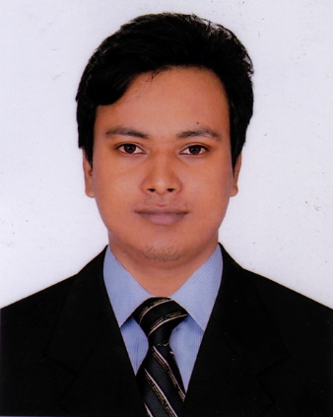
Md. Parvez

House: 05
Road: 13, Sector: 13
Uttara Model Town, Dhaka-1230,
Bangladesh
Cell: +880-1710005592
E-mail: parvezahmad460@outlook.com

Career Objective

Looking for a demanding career where I can employ my potentiality and skills to do something effective, inventive and productive. As a fresh graduate, I would like to illustrate my immense aspiration to demonstrate myself as a sincere, enthusiastic and energetic person through extensive hard working and integrity.

Education

- Bachelor of Arts (Honors)
Major: Apparel manufacturing & management & Technology (AMMT)
Institution: Shanto-Mariam University of Creative Technology
CGPA: 2.76 (Out of 4.00)
Passing Year: 2017

- HSC (Higher Secondary Certificate)
Group: Business study
Institution: Chowbari D. Salam Jahanara Degree College
Board: Rajshahi
GPA: 4.30 (Out of 5.00)
Passing Year: 2013

- SSC (School Secondary Certificate)
Group: Business Study
Institution: Chowbari Islamia High School
Board: Rajshahi
GPA: 3.50 (Out of 5.00)
Passing Year: 2011

Professional Experience

- Successfully attained and completed an Internship as an Industrial Placement at Mondol Group of Industry Ltd., Gazipur
Department: Merchandising and Production
Duration: Approximately Three Months

Personal Attributes

- Skilled, Serious and Sincere
- Honest and Result Driven
- Hard Worker and Creative
- Leadership and Time Management

Training and Workshops

- Attained in an International Workshop on Supply Chain Management Organized by Prothom-Alo Jobs and ISCEA
- Participated in a Training on HRM Organized by bdjbs, Bangladesh

Computer Competency

- Operating System: Windows 98 / 2000 / XP, Windows Vista
- Application Package: MS Office (Word, Power Point)
- Operating Proficiency: Internet Browsing, Web Access, E-mailing

Language Skills

- English: Can write, read, speak and understand (Moderately)
- Bengali: Can write, read, speak and understand (Native Language)

Achievements

- Achieved Best Student Award in Kinder Garden Level (Primary Phase)
- Accomplished Government Scholarship in Primary (Class Five) Level

Extra-Curricular Activities

- Cultural Programming and Participation
- Social Activities
- Writing and Acting

Active and Valued Membership

- Member of “Supply Chain Manager” Forum, ISCEA (Bangladesh)

Personal Profile

Permanent Address : Vill+Post- Chowbari,Thana- Kamarkhand,
Dist.-Sirajgong

Father’s Name and Occupation : Md. Litan Akanda, businessman
Mother’s Name and Occupation : Mst. Parvin Khatun, housewife
Nationality : Bangladeshi (By Birth)
Date of Birth : 10th November 1995
NID/Passport Number : 19958814476000464

References

Mr. MASUD AL NOOR
Designation: Head of department AMMT
Shanto Mariam University of Creative Technology
Room 2403, Campus-2 House# 06, Road # 14, Sector # 13
Uttara Dhaka 1230, Bangladesh.
Cell: 01677687310

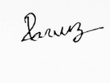

……………………………….
Md. Parvez
Date: 01/02/2018

