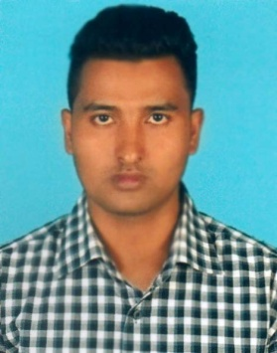
CURIICULUM VITAE
OF
MD. RAFIQUL ISLAM

MALLING ADDRESS:
Vill: Chandipasha, P.O: Nandail,
P.S: Nandail, Dist: Mymensingh
Contract: 01784-434948
01885-819856

CAREER OBJECTIVE:

Want to become a contributing member of an organization by using my skills and education efficiently and by working in a result oriented attitude.

CAREER SUMMARY :

Intend to work in a challenging and competitive environment where strong, sense of responsibility and commitment is required and where dignity of work provides job satisfaction and the place of work provides, potential avenues for learning, growing and achieving the top level hierarchy of the organization.

ACADEMIC BACKGROUND:

Bachelor Of Social Sciences (B.S.S)
Name of College : Shahid Smriti Adrasha College, Nandail.
Board : National University
Group : B.S.S
Passing Year : 2015
Result : 2nd Division

Higher Secondary Certificate (H.S.C)
Name of College : Shahid Smriti Adrasha College, Nandail.
Board : Dhaka
Group : Humanities
Passing Year : 2012
Result : GPA -3.40 (Out of 5.00)
Secondary School Certificate
Name of College : Goashpala Fazil Madrasah
Board : Madrasah
Group : General
Passing Year : 2010
Result : GPA -3.40 (Out of 5.00)

LANGUAGE KNOWLEDGE:
- Good at speaking and writing both in Bangla
- Good at speaking and writing both in English

HOBBIES & INTEREST:

- Reading Books, News Paper, Novel, TV News.
- Traveling at historical places.

COMPUTER LITERACY:

- Basic of Computer, operating System.
- Microsoft Word, Excel, Power Point,
- Keen user of internet and Web browsing,
- Typing good speed in English & Bangla and outlook good knowledge.

PERSONAL PROFILE:

Name : Md. Rafiqul Islam
Father’s Name : Md. Isreal Mia
Mother’s Name : Maleka Khatun
Permanent address : Vill: Chandipasha, P.O: Nandail
P.S: Nandail, Dist: Mymensingh
Date of Birth : 6th April, 1995
Nationality : Bangladeshi
Religion : Islam
Marital Status : Unmarried
Height : 5’-6”
Nid No : 19956127208000020
Blood Group : A+ (Ve)

STRENGTHS:

- Hard working under stress worthy environment.
- Quick learning decision making and rapid implementation.
- Taking changes to achieve the best result from assigned tasks.
- Good interpersonal skill in group based tasks.

CERTIFICATION :

I undersigned that to the best of my knowledge and belief this CV correctly describes my qualification and me. Any willful misstatement herein may lead to my disqualification of dismissal.

Md. Rafiqul Islam

Date:29.10.2018

