CURRICULUM VITA
Of
MD. TAHMIDUR RAHAMAN

MD. Tahmidur Rahman
Dewaner Chok
Sylhet, 3100
Cell: 01737-996940
E-mail: tahmidur.rahman093@gmail.com

C areer Objectives:
To build up the career by using my knowledge, perception and innovation and also build up the career through effective communication and decision making with organization that provides challenging rewarding environment.

Educational Qualifications :

Secondary School Certificate (S.S.C)
Name of School : Zahiria M.U High School, Sylhet.
Group : Humanities
Result : G.P.A-3.13
Board : Sylhet.
Year of Passing : 2008

Higher Secondary Certificate (H.S.C)
Name of College : Sylhet Gvt. College, Sylhet.
Group : Humanities
Result : G.P.A -2.70
Board : Sylhet.
Year of Passing : 2010

Bachelor of Social Science (B.S.S)
Institution : M.C. College, Sylhet.
Subject : B.S.S
Result : 3rd Class
Year of Passing : 2013
Board : National University

Language Skill : Spoken and Written communication Skill in both English and Bengali are Considered very good.

Personal Information :
Name : Md. Tahmidur Rahman
Father’s name : Md. Joynur Rahman
Mother’s name : Rekha Begum
Permanent address : Vill :- Dewaner Chok, P.O: Khadim nagar, P.S :- Sahporan (R) Modal, Dist :- Sylhet.
Mailing Address : Same
Contact no : 01737-996940
Date of birth : 06th aug 1990
Nationality : Bangladeshi
Religion : Muslim (Sunny)
Marital status : Single

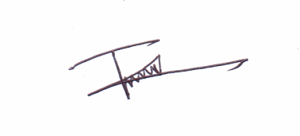

Date : 26-09-2016 Md. Tahmidur Rahman

