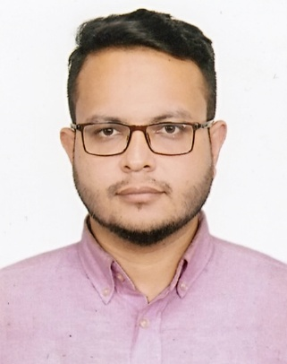
Curriculum Vitae of
Md. Tanvir Hasan
3/2/1-B, Borobag,
Mirpur-2, Dhaka.
Cell: +88 01717588955
E-mail: showruv27@gmail.com

Career objective

- I am interested to work in a dynamic, travelling, exciting, challenging, creative and service oriented organization where I can explore my creativity and use my academic and working knowledge and expertise properly.
Career Goal

- Want to show my efficiency in Company's future flurries.
- Set up a Positive impression that lead the company's progress.
- Be an obedient employee.
- Desired to a successful.

Language Competency

- Bengali-Mother Tongue.
- English –Fluent both in Speaking & Writing.

Educational Background

  - BSc Engineering
University : European University of Bangladesh
Department : Electrical & Electronic Engineering ( EEE )
Result : 7th Semester Running

  - Diploma Engineering
Academic Institution : National Polytechnic Institute
Subject : Electronics
Board : BTEB
G.P.A : 2.88 in the Scale of 4.00

  - Secondary School Certificate (SSC)
Academic Institution : Begumgonj Govt. Technical High School, Nohakali
Group : Science
Board : Comilla
G.P.A : 3.44 in the Scale of 5.00

Computer Skills

- MS Word, MS Excel, Power Point etc.
- Computer Official Work.
- Online Work.
Page 1 of 2

Personal details

- Father’s Name : Md. Amirul Islam
- Mother’s Name : Jahanara Begum
- Permanent Address : Vill: Aliarpur, P.O: Begumganj,
P.S: Aliarpur Kazir Haat, Dist: Noakhali.
- Date of Birth : 27th November’ 1992
- Nationality : Bangladeshi (By Birth)
- Religion : Islam
- Place of Birth : Noakhali.
- Marital Status : Married
- Gender : Male
- Height : 5'-6"
- Blood Group : O+ (ve)

Interest

  - Traveling
  - Chatting
  - Playing Cricket etc.

Experience

- Name of the Organization : Global Fashion Ltd. (Azim Group)
Designation : Q.C (Supervisor, Sample Section)
Duration : 2nd October, 2018 to till now.
- Name of the Organization : Star Link
Designation : Junior Engineer
Duration : 17th August, 2017 to 30th September, 2018.
- Name of the Organization : Patron Saint (IELTS & Higher Education)
Designation : Promotion & Marketing Officer
Duration : 2016 to 2017, July
Reference

1. Md. Firozul Islam 2. Engr. Md. Abdul Malek
Manager (Merchandising) Project Manager
Azim Group, Dhaka Star Link, Dhaka
Mob: 01711932040 Mob: 01755543131
Declaration

- I do hereby declare that the statements mentioned above are true and correct.
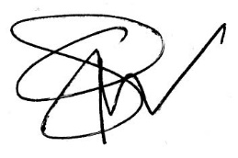

(Md. Tanvir Hasan )

Date: Signature

Page 2 of 2

