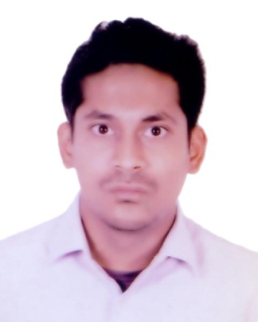
Résumé OF

Md. Tareq Aziz

ADDRESS:
79, West Monipur, Mirpur-2, Dhaka-1216
Mobile: 01682623978
Email: tariqaziz88@gmail.com

Career Objective:
To work and build up a career in a reputed organization where I will have the maximum exposure to cope up with the challenges I will come across and make the best use of my wit and potential to meet up any given challenges successfully.
Work Experience:
- Britex Sportswear Ltd.:

Designation : Intern
Department : Merchandising Department
Duration of Work : January, 2017 to March, 2017
Education:
Bachelor of Science (Hons.), 2017
Major in Knitwear Manufacture and Technology
BGMEA UNIVERSITY OF FASHION AND TECHNOLOGY, Dhaka (2013, spring to 2017, fall)
Higher Secondary Certificate, 2012
Business Studies
Mirpur University College, Mirpur-2

Secondary School Certificate, 2010
Business Studies
National Bangla High School.

Computer Skills:
- Ms-Office 1997 to 2010, Windows-1995, 97, 2000, XP 7, 8 & 10, MS-DOS.
- Google Drive

Communication Skills:
- Proficient In Bangla & English (Both verbal & English)
- Ability to organizing and conduction seminar or any events and also I can give multimedia presentation as well as report writing.
Extra Curriculum Activities:
- Google Map Making, Internet Browsing etc.
Field of Interest:
- Prayers, Music, Cricket, Movies, Travelling and gossiping with family. Also try to discuss with new business plan.
Skills and Competencies:
- Ability to work under pressure
- Ability to work alone or with a team
- Strong Communication Skills.
- Ability to make good relation with anyone
- Quick Learner, self motivated, proactive & committed

Personal Details:

Father Name : Md. Salim Khan
Mother Name : Nasima Khan
Permanent Address : 79, West Monipur, Mirpur-2, Dhaka-1216.
Nationality : Bangladeshi
Religion : Islam
Date of birth : 27 November, 1994
National ID : 6429214908

References:

Md. Rafiqul Islam Manik
Lecturer, BUFT
Department Of Knitwear Menufacture and Technology (KMT)
E-mail: rafiqulislam@buft.edu.bd

Md. Shahidul Haque
Senior Lecturer of BUFT
Department of FDT
Director Spark Knit Composite Ltd
Factory: Zerune, Konabari, Joydebpur, Gazipur.
Contact: 01813334327.

