MD. MEHEDI HASAN
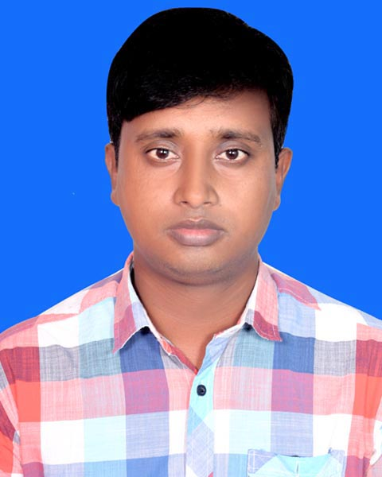
Current Address: Matarbari, Moheshkhali, Cox’sbazar
Chattogram, Bangladesh.
Mobile No.: +88 01721513205 (WhatsApp)
E-mail : engr.eeemehedi@gmail.com

CAREER SUMMARY:
I have work experience of more than 7 years which includes working with Felix Control Limited to conduct Installation Commissioning Maintenance of Electrical, HVAC, BMS, IBMS, Fire detection, Access Control, CCTV, Traffic Control, Energy and Cooling meters control Systems. Extensive knowledge of electrical engineering design and applications. Able to provide technical leadership within a multidisciplinary team environment. Currently I am working in Penta-Ocean Construction Co,. Ltd. In the project of “Matarbari Ultra Super Critical Coal-Fired Power Project, Package 1.2” as a Electrical Engineer for the Mechanical & Electrical Department (Installation Maintenance Inspection Mechanical & Electrical Machineries , Reporting etc). The operation in Penta-Ocean includes health and safety risk assessment for worksites to adapt with unique technical and worksite conditions.

PROFESSIONAL EXPERIENCE:
1. ELECTRICAL ENGINEER (JANUARY 19, 2019 – PRESENT)
PENTA-OCEAN CONSTRUCTION CO., LTD.
Address: ​Rangs Hai-Legacy, Flat-4A, H# 13, Shohrawardy Avenue, Baridhara, Dhaka-1212, Bangladesh.

Project: Procurement of Power Plant and Port Facilities Under Matarbari 1200mw Ultra Super Critical Coal-Fired Power Project, Package 1.2, Moheshkhali, Cox’sbazar, Chattogram, Bangladesh.
‘

Duties/Responsibilities:
- Planning, Execution, Installation, Testing and Commissioning of Electrical System.
- Installation Operation and Maintenance of 600KVA,300 KVA,100KVA,60KVA Diesel Generator, Tower Light.
- Operation and Maintenance of Sub-Station, Synchronization panels, Utilities and Machineries
- Installation Operation and Maintenance Reefer Container.
- Supervise and manage vendor engineering and equipment deliverable to ensure compliance with project standards and specifications.
- Daily Power monitoring, calculations and reporting at monthly basis.
- Responsible for maintaining an inventory for the requirement of the supplies and
spare parts.
- Identified specific cables, connectors, fuses, circuit breakers and other electrical devices required for installation of monitoring systems
- Responsible for power supplier, generators, distribution of loads + cabling Accommodations, Offices (power supplier, refrigeration, lighting, TV, Air Condition).
- Mentored junior engineers and new hires to better improve competency and efficiency of all staff.
- Attend daily meeting in office, Daily Maintain whats app group.

2. Sr. Executive Engineer (SEPTEMBER 1, 2012 – DECEMBER 31, 2018)
FELIX CONTROL LIMITED.
Address: ​147/1, Monipuripara (4th floor), Tejgaon, Dhaka, Bangladesh.

Duties/Responsibilities:
- Designing Electrical, HVAC, BMS, IBMS, Fire detection, Access Control, CCTV, Traffic Control, Energy and Cooling meters control Systems.
- Installation, Erection, Operation, Maintenance, Testing, Commissioning and Servicing of systems and equipment.
- Reading design specifications and technical drawings.
- Researching suitable solutions and estimating costs.
- Identifying client requirements.
- Communicating with clients and contractors.
- Preparing work documentation, writing reports and giving presentations.
- Attending meetings on site.
- Project Management & Inspection Consultation.

Major Projects:
- HVAC Control System for Essential Drugs Company Limited (EDCL), Gopalganj
- HVAC Control System for Beximco Pharmaceuticals Limited, Cherag Ali,Tongi
- BMS. IBMS, Access Control, CCTV, Car Parking Management ,3 Basement+15 Storied at Eastern Bank Limited HQ, Gulshan,Dhaka
- HVAC Control System for Potent Product Facility of Acme Laboratories Ltd.
- HVAC Control System for New Oncology Facility of Eskayef Bangladesh Ltd.
- BMS, IBMS & Car parking management, 3 basement +14 storied at Zam Zam Tower, Uttara, Dhaka.
- BMS. IBMS, Access Control, CCTV, Car Parking Management ,3 Basement+14 Storied at Shahjalal Islami Bank Limited HQ, Gulshan, Dhaka
- BMS System Franco German Embassy,Gulshan ,Dhaka
- BMS, CCTV, Access Control System, 2 Basement+13 Storied at Arhum Tower,Uttara,Dhaka.
- BMS, IBMS, Access Control System, 2 Basement + 13 Storied at Bay 23,Gulshan,Dhaka
- BMS & Access Control System, 2 Basement +14 Storied at Bay Edge Water, Gulshan ,Dhaka.
- BMS & IBMS at Election Commission, Agargaon, Dhaka.
- BMS at QA Group ,Gulshan Tejgaon Link Road, Dhaka.
- BMS IBMS & Access Control System, 2 Basement + 10 Storied at BSMMU Oncology, Shahabag,Dhaka

FIELD OF SKILL:
- ► Drawing ► Design ► Project management ► Technical support ► Estimating
► Ability to Work Alone & Team under Pressure ► Reporting ► Sincere and Hard worker

- Basic Knowledge, Internet Browsing, MS Word, MS Excel, MS PowerPoint, Capability of typing Bengali Language (Bijoy), Adobe Photoshop, Windows Operating System.

ACADEMIC QUALIFICATION:
Exam Title | Concentration/Major | Institute | Result | Passing Year | Duration
B.Sc in Electrical & Electronic Engineering | Major : Power | Green University of Bangladesh | CGPA:3.00  out of 4 .00 | 2016 | 4 Years
Diploma in Engineering | Electrical Technology | Bangladesh Polytechnic Institute (BPI) | CGPA:2.99  out of 4 .00 | 2012 | 4 Years
Secondary School Certificate | Humanities | MR High School | CGPA:3.75  out of 5 .00 | 2006 | 2 Years

LANGUAGE PROFICIENCY:
Language | Reading | Writing | Speaking
Bangla | High | High | High
English | High | High | Medium
PERSONAL INFORMATION:
Father’s Name : Md. Afjalur Rahaman
Mother’s Name : Mst: Momotaj Begum
Date of Birth : October 15, 1990
Gender : Male
Marital Status : Married
Nationality : Bangladeshi
National ID : 19906914485000112
Religion : Islam
Blood Group : O + (Positive)
Present Address : Matarbari, Moheshkhali, Cox’sbazar, Chattogram, Bangladesh.
Permanent Address : Vill: Ramkrisnapur, P.O: Lalpur , P.S: Lalpur, District: Natore.

REFERENCES:
Reference-01 Reference-02
Name : Jubaer Hossain Muhammad Aziz Zeisan
Organization : Felix Control Limited Felix Control Limited
Designation : Managing Director Manager, Engineering
E-mail : jubaer@felixbd.com aziz.zeisan@felixbd.com
Mobile No. : +880 1711688680 +880 1708-814501

DECLARATION OF AUTHENTICITY:
I, Mehedi, hereby declare that the above- furnished information is true to the best of my knowledge and belief.
Date: November 1, 2019
Signature

