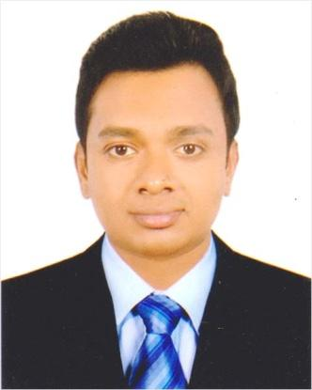
CURRICULAM VITAE

Md. Mehedi Hasan
Mobile :01913163759
E-mail: bappyhasan427@gmail.com

Career Objective :

As a graduate I would like to show my immense aspiration to become a quick learner and to become a quick learner and to prove myself as a sincere, self-motivated and energetic person through extensive hard work and integrity.
Education :
M.B.A
- GPA- 2.78
- Management
- Year of examination-2016
- National University.
- Khilgaon Model University College.

- B.B.A (4 Year)
- Management
- GPA-2.82
- Year of examination-2015
- National University.
- Khilgaon Model University College.

Higher Secondary Certificate ( H.S.C)
- Passed with 3.40
- Year of examination 2011
- Business
- Khilgaon Model University College.

Secondary School Certificate ( S.S.C)
- Passed with 3.00 in 2009
- Business
- Shamaspur High School.

Strengths, Skills and Abilities :
- Good communication & presentation ability.
- Can work under pressure.
- Can work independently and as a member of any team.
- Having god skills in planning, organization & monitoring.
- Strong work ethic under pressure.
Computer Skills :

- Working Environment : Windows 7, Windows XP
- Word Processing : MS Word
- Spreadsheet : MS Excel

Language Skills :

- English : Excellent writing & Communication Skills.
- Bangla : Excellent Writing & Communication Skills.
Job Experience :
- Duties/Responsibilities : Contact People/Customers Promoted Company's
Product Sales And Marketing Commercial , Merchandising., Ngo.
- Telereal Ltd. Video Editor ( 1 Year) .
- Elegant real estate/developers Ltd. Project manager ( 1 Year ) .
- The Fashion Island Ltd. Merchandising (1 Year ) .
- The Fashion Island Ltd. Commercial (1 Year ) .
- Blind Education and Rehabilitation Development Organisation (BERDO).
Teacher ( 2 Year) .
- Cash transfer project . Christian Blind Mission Bangladesh ( CBM ) , Facilitator (6 months ) .
- Collective Efforts of Organization of Persons with Disabilities on Inclusive COVID-19 Humanitarian Actions In Bangladesh “ Project ” Centre For Disability Development Bangladesh CDD , ADFP (1 Year ) .
- Street Sports Bike Shop. (Monitoring Officer ) Delivery of Yamaha Bike ,
E- Commerce Companies ( 8 Month ).

Personal Details :

Father’s Name : Md. MotiarRahman
Mother’s Name : Beauty Begum
Permanent Address. : Mawa kumervok purnovason chandro,
Louhajong, Munshiganj.
Present Address : House-16, Road- 05, Block-A, Basnsrree Rampura, Dhaka-1219
Date of Birth : 10/05/1992
Sex : Male
Religion : Islam(Sunni)
Nationality : Bangladeshi(By Birth)
Marital Status : Married
Blood Group : B+
Reference :

Brother
Md. Kamrul Hasan (Liton)
Bangladesh Television BTV
Programmer
Rampura, Dhaka-1219
Mobile: 01712427873

Md. MehediHasan Date:

