Resume
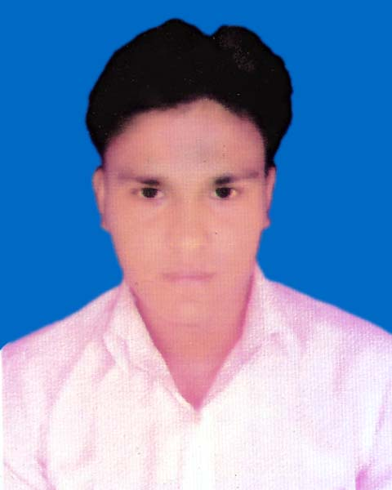
Of
MEJBAUDDIN MOLLA
Vill: Shaikhpura, Post: Shially,
P.S: Terokhada, Dist: Khulna.
E-mail:- majbauddin2070@gmail.com
Phone: 01967-573488

Career Objective:

Develop a Successful career thought hard work. Suitable job position where nice working environment, decision making opportunities, qualities and good career can be assured, I want to build up myself as anupdated citizen of modern civilization.

Self-Assessment:

I am amiable, friendly, hospitable and unique organization with ability to foresee the future.
I was not quarrels for mini matters as regular features at all.
I never failed to keep my words given to other.
Belief in team work.
Efficient in time and crisis management.

Educational Qualification:

Examination : Bachelor of Arts (BA) Hon’s
University : Govt. B. L. College
Passing year : 2015
Result : 1st Class

Examination : Higher Secondary Certificate (H.S.C)
College : Chandpur College, Rupsha
Passing year : 2011
Group : Humanities
Board : Jessore
Result : 4.30(GPA)

Examination : Secondary School Certificate (S.S.C)
Institute : Goara High School, Rupsha
Board : Jessore
Group : Humanities
Passing year : 2009
Result : 3.56 (GPA)

Language Proficiency:

Bangle : Proficient speaking listening and writing as its mother tongue

English : Proficient speaking listening and writing.

Personal Information:

Name : Mejbauddin Molla
Father’s Name : Ibrahim Molla
Mother’s Name : Sima Khatun
Date of Birth : 25/10/1994
Place of Birth : Khulna
Nationality : Bangladeshi (By Birth)
Religion : Islam
Marital Status : Single
Height : 5.7
Blood Group A+ (ve)

Interest and Hobbies:

 ReadingTraveling Presentation Networking  Serve the humanity Music

Reference:

Md. Alam
Khulna DC Office
Office Asst.
Cell – 01981-891874

____________________
Mejbauddin Molla

Date:

