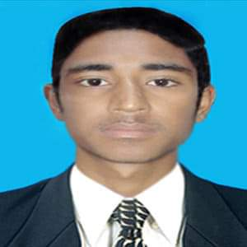

Scaner at Secondary & Higher Secondary Board
Alampur, Sylhet
2019 – 2020 (Due to Covid-19 project had stopped)
Higher Secondary Certificate (H.S.C)

Board: Sylhet Result: GPA (4.42) Science

Passing Year: 2016
+880 1725723413
As. teacher at Govt. Primary School
Writing Poetry & Article
Reading
Md. Milon Rana
Computer Trainer at NIT, Sylhet.
Puran-Lane, Bondor Bazar, Sylhet-3100, Sadar, Sylhet.
2019 – Present (Part Time)
Experience
Passing Year: 2014
Board: Sylhet Result : GPA (5.00) Science

Secondary School Certificate (S.S.C)

M.C. College, Sylhet.
2016 - 2017
B.Sc. Honours in Botany (3rd Year)
MOTIUR RAHMAN
Painting
Swimming
Football
Ayesha Begum
+880 1678313314
Manager at NIT, Sylhet.
Typing
Ms Office
Illustrator
Photoshop
I want to achieve an appropriate place in a renowned Organization from where I can get the facilities to develop myself and to learn. Also I would like to actualize the theoretical knowledge of business administration in the practical arena through working in an organization with the global exposure.

Skills
Hobbies
Reference
Education
About Me
letustry98@gmail.com
West Vatpara, Islampur-3100, Shahporan,Sylhet
+880 151716 0583
Post: Help Desk Executive

