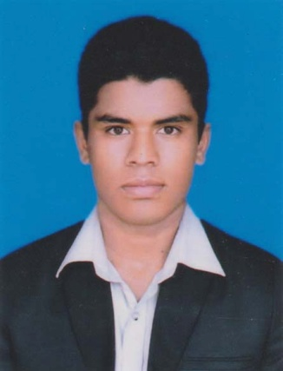
CURRICULUM VITAE
OF
MD. KAJOL HOSSAIN

Phmohammadkazol6565@gmail.com
Cell: 01725-936265

Carrier Objectives:
I am looking a position in such an organization where I will find the ample scope to work and get an opportunity to promote myself and make a career in any.

Education Background

Diploma in Pharmacy:
Name of Institute : TMSS Medical Technology Institute, Bogura
Subject : Pharmacy
Result : Passed
Passing Year : 2017
Board : Pharmacy Council of Bangladesh, Dhaka

Secondary School Certificate (S.S.C)
Name of Institute : Selonda High School
Group : Science
Result : G.P.A- 4.25 (Out of 5.00)
Passing Year : 2013
Board : Rajshahi

Computer:
Name of Institute : Prime Computer Training Institute
Group : Certificate In Database Programing (6 Month)
Result : G.P.A- 5.00 (Out of 5.00)
Passing Year : 2017
Board : Bangladesh Technical Education Board, Dhaka

Computer Skills:
M.S. Word, M.S Excel, M.S. Power Point, M.S. Access, Internet Browsing etc.

Personal Characteristics:
Strong analytical and leadership skill Excellent interpersonal and communication. Ambition and target oriented and field Related work. Capable of adapting in any type of environment. Capable to cope with people at every level. Team’s spirit’s ability. Problem solving and initiative, ability.

Field Training :
I have work 18 weeks in the Field Training in outdoor dispensary, Drug store, Operation theater (O.T). Emergency Department, O.R.T Corner with Diarrhea Ward, Medicine Ward, Surgery Ward, Pediatric Ward and Outdoor Medicine, Surgery, E.N.T, Skin, Eye, Dressing Room in Shaheed Ziaur Rahman Medical College Hospital, Bogura.

Language Capabilities:
Bengali : Excellent Reading, Writing & Speaking.
English : Excellent Reading, Writing & Speaking.

Job Experience:
Worked as a Pharmacist in Current Pharma since September 3 to December 14
Working as a Pharmacist in Care Medical College & Hospital since January 20 to Present.

Hobby:
Reading, Cricket, Music, Travelling, Build up Relationship, Exercise.

Personal Information:

Name : Md. Kajol Hossain
Father’s Name : Md. Mohammad Ali
Mother’s Name : Mst. Rohima Khatun
Present Address : Jigatola, Dhanmondi, Dhaka-1209
Permanent Address : Vill: Atiapara, P.O: Selonda,
P.S: Shanthia, Dist: Pabna.

Date of Birth : 8th March 1997
Nationality : Bangladeshi (by birth)
Religion : Islam
Marital Status : Unmarried
Gender : Male
Blood Group : B + (ve)
Height : 5’5’’
Contact Number : 01725-936265

C/O:
Mohammad Ali
Cell: 01424427083
Confidence:
I am smart, young energetic, dynamic, an outgoing pleasent personality and self- starter, strong interpersonal skill with an ability to work at a high pace on one’s own initiative.

Signature: ...........................
(Md. Kajol Hossain)

Date: ..................

