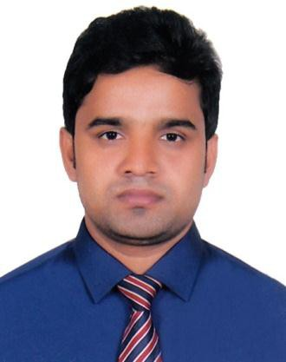RESUME

OF
MOHAMMAD SAHEDUL ISLAM
Mailing Address :
Kulsuma Bhaban, 945/B,Chand Mia Munshi Lane,
D.C. Road, Chawkbazar, Chattagram.
Contact No: 01774131448, 01533093387
Email: sahedijs6454@gmail.com

 | OBJECTIVE | With an EMBA degree under University of Chittagong and an internship experience at a leading bank, I have developed solid leadership and management skills; Seeking a position to bring forth innovative ideas, analytical approach along with superior  knowledge and organizational abilities.
 | ACADEMIC QUALIFICATION |  | TITLE : Masters of Business Administration (EMBA) Institution : Chittagong University Centre of Business Administration Subject : Finance & Banking  University : University of Chittagong.  Result : CGPA-3.03  Year of Passing : 2016  TITLE : Masters of Business Studies (MBS)  Institution : Govt. Hazi Mohammad Mohsin College  Subject : Accounting  University : National University  Result : 1st Class (65%)  Year of Passing : 2013  TITLE : Bachelor of Business Studies (BBS)  Institution : Govt. Hazi Mohammad Mohsin College  Subject : Accounting  University : National University  Result : 2nd Class (57%)  Year of Passing : 2012  TITLE : Higher Secondary Certificate (HSC)  Institution : Moheshkhali Degree College  Group : Business Studies  Board : Chittagong  Result : GPA- 4.40 (Out of 5.00)  Year of Passing : 2008  TITLE : Secondary School Certificate (SSC)  Institution : Moheskhali Model High School  Group : Business Studies  Board : Chittagong  Result : GPA- 4.38 (Out of 5.00)  Year of Passing : 2006
 | Training | - Internship in Performance an Evolution of Bangladesh automated Clearing House at First Security Islami Bank, Chawkbazar, Chittagong For 6 months.
 | EXPERIENCE : | - Worked as an Assistant Teacher at Abdul Mabud Chowdhury High School, kerontali, Howanok, Moheshkhali, Cox’s bazar from 01/09/2017 to 1/10/2018.

LANGUAGE | Bengali : Reading, Writing, Listening & Speaking.  English : Reading, Writing, Listening & Speaking.

COMPUTER SKILL: | - Microsoft Office Package (MS Word, MS Excel, MS PowerPoint etc.)
SELF ASSESSMENT | - Excellent communication presentation skills.  - Team player who believes in knowledge sharing and collaboration.  - Self-motivated, confident, optimistic and willing to take challenge.  - Energetic, sincere, hardworking and friendly as a person.

PERSONAL INFORMATION | Full Name : Mohammad Sahedul Islam  Father’s Name : Badsha Miah  Mother’s Name : Nayera Begum  Permanent Address : C/O- Badsha Miah Bari, Vill: Gorakghata  P.O: Gorakghata, P.S: Moheshkhali, Dist: Cox’s Bazar.  Date of Birth : 1st January, 1990  Religion : Islam  Nationality : Bangladeshi (by birth).  National ID : 2224908108194  Blood Group : A+  Height : 5 feet 5 inch  Weight : 63 kg

REFERENCE | Md. Borhan Uddin Khan  First Assistant Vice President & Head of Branch  Islami Bank Bangladesh Ltd. Baraiyarhat Branch, Miyazi Market, Baraiyarhat , P.S: Jorargonj, Mirsharai, Chattogram.  E-mail: burhan4303@gmail.com Cell: 01613716041  Relation: Uncle (Maternal) | Nasrin Sultana  Lecturer in Economics  Govt. Hazi Mohammad Mohsin College Chattogram  Cell: 018153333622  Relation : Cousin

VALUATION | I Certify that all information provided in this RESUME is true and complete to  the best of my knowledge. I appreciate any kind of verification about all the information are provided here


Sincerely Yours

_______________________________
(Mohammad Sahedul Islam)

