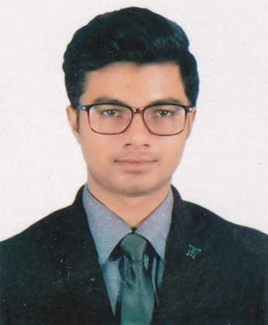
_{Résumé}of
Mohammad MojammelHoque
Cell No: +8801686675570
E-mail: mojammelhoque003@gmail.com
Uposhohor, Block-D, Road No-24, Sylhet.

OBJECTIVE
I am self-motivated, committed and am able to provide strong leadership and build relationships. I enjoy working in a team and want to be part of a team where I can pursue my proven & potential skills in managing business, people and team leadership. I am seeking responsibilities and opportunities in those areas where academic background and skill can be exercised.

EDUCATIONAL STATUS

Program: Bachelor of Tourism & Hospitality Management
Passing Year: 2018
Institution: World University of Bangladesh, Dhanmondi, Dhaka
CGPA: 3.10

Exam: Higher Secondary Certificate
Board: Sylhet
Year: 2013
Institution: Sylhet Govt. College, Sylhet
Group: Science
Result: GPA- 3.60

Exam: Secondary School Certificate
Board: Sylhet
Year: 2011
Institution: Osmani Medical High School, Sylhet
Group: Science
Result: GPA-4.44

COMPUTER SKILLS
- Operating System: Windows XP, 2000, 2007, 8, 8.1
- Package Program: MS Office (MS Word, MS PowerPoint)
- Networking: Advanced Web Browsing, Internet Searching

AREA OF INTEREST

- Public Relations
- Reading
- Travelling
- Do the new thing

STRENGTHS

- Have leadership quality
- Honest and sincere to work
- Dynamic, Communicative and self motivated
- Good organizer and have managing skills
- Good oral and written command over Bengali and English
- Hard working and capable of working under pressure.

PERSONAL ACCOUNT

Name: Mohammad MojammelHoque
Father’s Name: Md. Akter Uddin
Mother’s Name: Ranuara Begum
Date of Birth: 07/07/1995
Nationality: Bangladeshi
Religion: Islam
Marital Status: Single
Blood Group: O (+ve)
Height: 5‘ 4“

Permanent Address: Village- Shatpari,
Post Office- July,
Upazilla- Kanaighat,
District- Sylhet

Present Address: Uposhohor, Blcok-D, Road No-24, Sylhet

Cell No: +8801686675570

REFERENCE

Mohammed Nasimul Azim
Chief Executive Officer,
Western Group
18, KaziNazrul Islam Avenue,
Shahbagh, Dhaka- 1000

Professor,
Department of Tourism & Hospitality Management
World University of Bangladesh
Dhanmondi, Dhaka- 1205
Cell: +8801712185722
E-mail:nasimbabu@hotmail.com

Mohammad Mojammel Hoque

