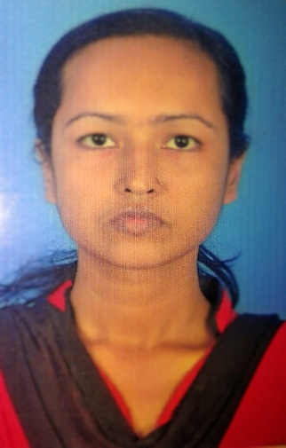
Momotaz Begum
Mob:+8801879259295
Email: momotaj.bd@outlook.com
Address: Block-D,House no-79,Shobujshena,Mullapara, Sylhet, Bangladesh.

OBJECTIVES
# To explore myself as a confident and professional competent.
# To take challenge of competitive and dynamic business environment with
commitment
ACADEMIC QUALIFICATION
Bachelor of Arts
Sunamgonj Govt. College, Sunamgonj Year of passing:2013
CGPA: 1st Class
Higher Secondary Certificate(H.S.C)
Year of passing:2009
Institution : Sunamgonj Govt. College, Sunamgonj
Board : Sylhet
Group: Humanities
CGPA: 3.10 (on the scale 5.00)
Secondary School Certificate(S.S.C)
Year of passing:2007
Institution: Sunamgonj Technical School & College, Sunamgonj
Board:BTEB
Group:Refrigeration &Air Condition , CGPA: 3.59 (on the scale 5.00)

LANGUAGE PROFICIENCY
English: Fluent at reading, writing, speaking and listening.
Bangla: Mother tongue.
TRAINING
6 month training on Computer Application in Ideal Computer Centre, Sylhet

PERSONAL DETAILS
Father’s Name: Md. Shanwar Uddin
Mother’s Name: Mayrom Begum
Date of birth :April, 27, 1989 Nationality: Bangladeshi
Religion: Islam ( sunni )
Sex :Female
Blood Group: AB+ Marital Status : Unmarried Permanent Address : Soyket 42, South Arpinnagar, Sunamgonj. Present Address : Shobujshena 79, Block-D, Mullapara, Sylhet

INTERPERSONAL SKILLS
# Ability to management with efficiency at all levels.
# Well discipline and self motivated.
#Helping to others.
#Tendency to work harder.

Computer Literacy
Application software :Adobe photoshop , Illustrator, MS Word, MS Excel,
MS Power point. Internet: Browsing Internet and E –mail.

EXTRA EXPERIENCE
Worked as tax collector in N.Z.Consultancy Firm Ltd. For 6 month

REFERENCES

Proffessor Shankar Chowdhury Professor Dr. Abul Fateh Fattah
Head Principal
Department of Economics Madan Mohan College, Sylhet
Madan Mohan College, Sylhet Mob: 01912712476
Mob : 01715575184

CERTIFICATION I , the undersigned, certified that:
To the best of my knowledge and belief, this resume correctly described myself, my qualification.
I understand that my willful misstatement in this resume may lead to my disqualification or dismissal, if engaged.

¨¨¨¨¨¨¨¨¨¨¨¨¨¨¨¨¨¨¨¨¨¨¨¨¨¨¨¨
Momotaz Begum
Date:.................

