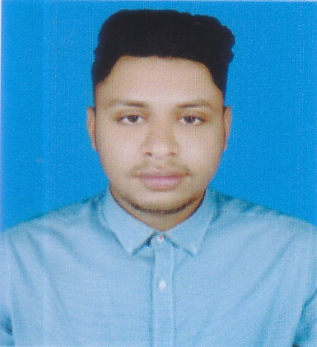
Resume Of
MORAD HASSAN SHIMUL
Contact Address:
Morad Hassan Shimul
(F-189 Uttor Chayabeethi), joydebpur Gazipur .
Mobile : +8801632009437
e-mail : moradshimul1996@gmail.com

PROFESSIONAL INTEREST

To work in a challenging and dynamic position at Global Standard Organization with a vision of dedication, where job satisfaction and career building could be achieved through hard work. I would also like to enter into a service-oriented organization where it is fairly possible to exploit and utilize my skills and experiences.

PROFESSIONAL EXPERIENCE

Saif powertec limited.
E-Engineering limited
95 khawaja tower (13th floor).
Mahakhali Dhaka -1212
Project:Payra Rehabilitation project
(Package-1,2,3,7,11,12,13,14)
Position : Store keeper (In- charge)
Period: 1st Augest2018 to till Date.

PERSONAL STRENGTHS:

# Self –organized proactive and quick learner.
# Strongly believe in honesty and dignity. I have what it takes to be a true professional.
# Willing to accept any challenging assignment.
# Like to lead and coordinate group works.
# My cross-disciplinary exposure makes me confident in managing a wide range of work. I can cope up with stress and contingencies.

AREAS OF RESPONSIBILITIES:

# Managing and Handling that work in the store is going smoothly.
# Managing the store day to day operation of store update invoices and documents of the items on the daily basis.
# Handling activities in store to ensure proper recording of outgoing materials.
# Arrangement for inventory stacking and their maintenance in Rack, Rows & Bins.
# Time to time follow-up the materials position and up-date latest position through format for in time procurement.
# Receiving panel, Inverter, Charge controller and other materials from C&F other suppliers.
# Ensure security system of the store.
# Ensure FIFO method and Clarify the product date of expire.
# Inter- departmental coordination in line with the Company’s policy and procedures. # Responsible for handling Distributors and their queries.
# To attend buyer meeting & submit meeting report to all relevant concerns.
# Maintain the records of all Enter & Issue by the MS Excel database.
# To follow up production situation.

AREAS OF INTEREST

- As a counselor (Admission & Information)
- As an Administrative Officer
- Office Management
- Customer Service

EDUCATIONAL BACKGROUND

Degree/Certificate | : Bachelor Business Administration (BBA). (Runing – 6 th Semester)
Department | : Accounts
Name of institute | : Model Inistitute Since Of Tcehnology (MIST)
Board/University | : National University.
Degree/Certificate | : Higher Secondary School Certificate (HSC).
Department | : Commerce
Name of institute | : Gazipur Matropoliton Collage
Board/University | : Dhaka Board
Degree/Certificate | : Secondary School Certificate (SSC).
Department | : Commerce
Name of School | : Rani Bilashmoni Govt. Boys High School
Board/University | : Dhaka Board

COMPUTER SKILLS

▪ Application Software:

▪ MS Office 97, 2000 &2003, MS Excel 7.0, MS Power Point7.0 Internet Communication, Browsing and exchange emails.

LANGUAGES & DEGREE OF PROFICIENCY

Language | Speaking | Reading | Writing
English | Good | Excellent | Good
Bengali | Excellent | Excellent | Excellent

STRENGTH:

Interpersonal skill, self-motivation, Team worker and Willingness to work hard to build career.
PERSONALDETAILS:

Name | : Morad Hassan Shimul
Father’s Name | : Jahangir Allom
Mother’s Name | : Halima Khatun
Date of Birth | : 06th Aug, 1998
Nationality | : Bangladeshi (By Birth)
Passport NO | : BX 0342003
Religion | : Islam.
MaritalStatus | : Unmarried
Permanent Address | : F-189 Uttor Chayabeethi), joydebpur Gazipur
References:

Md. Aminuzzaman  Director  Saif powertec limited.  E-Engineering Limited.  95 khawaja tower (13th floor).  Mahakhali Dhaka -1212  Cell: +8801787684244 | Hasibul Hasan Sabuj  Admin & Lojistics officer  E-Engineering Limited  95 khawaja tower (13th floor).  Mahakhali Dhaka -1212.  Cell: +88 01718416251

CERTIFICATION:

I, the undersigned, certify that the mentioned information have correctly described my qualifications, experiences and myself to the best of my knowledge.

_____________
Morad Hassan Shimul

