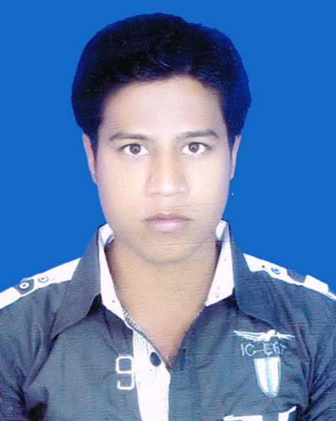
CURRICULAM VATE
OF
Md. Mostafizur Rahman
Mobile No: 01750-891400

Career Objective:
To build up a challenging career as devoted, trustworthy as well as competent worker in a dynamic a learn environment and encourage optimization of my abilities.

Career Strength:
I belive that my academic degree and other qualification will provide me necessary supports that will help my flourish career.

Academic Qualification
B.B.S (pass)
Medium of Education : Business Studies
Name of institute : Darsana Govt. Colleg
University : National University
Result : Scond Class
Passing Year : 2012

Higher Secondary Certificate (H.S.C)

Medium of Education : Commerce
Name of institute : Darsana Govt. Colleg
Board : Jessore
Result : 2.60
Passing Year : 2010

Secondary School Certificate (S.S.C)

Medium of Education : Commerce
Name of institute : Hasadha Bohmukhe High School
Board : Jessore
Result : 3.06
Passing Year : 2007

Computer Proficiency :
- MS Word, MS Exel, MS Access, MS Power Point, Photoshop & Internet Browsing etc.
- Certificate in Computer Office Application Programming.

Language proficiency
Languege | Reading | writing | speaking
Bangla | high | high | high
english | high | high | medium

Experience
Field Organiger
Micro finance of Jagorani Chakra Foumndation at two years.

Personal Information:

Full Name : Md:Mostafizur Rahaman
Father’s name : Md:Mosharef Hossin
Mother’s name : Mst.Rasida Begum
Present Adress : Vill:Krisnopur , Post: Darshanaa, Thana: Chuadanga , Dist: Chuadanga
Parmanent Adress : Vill:Krisnopur , Post: Darshanaa, Thana: Chuadanga , Dist: Chuadanga
Date of Birth : 25/August/1992
Email : Mostafizurdkp@gmail.com
Nationality : Bangladeshi
Religion : Islam
Sex : Married
Blood group : B+
Place of Birth : Chuadanga
National Id no : 1992182323000270
Hight : 5 fit 5in

Reference:

Md: Shirajul Islam
Field Organiger
Micro finance & Farmer Devoelopment foundation of Bangladesh.
Chuadanga Police Line, Chuadaga.
Mobile no: 01926-204711

Mst. Zinzira Khatun
Assistance teacher
Bishnopur Secoundary School
Dhamurhuda, Chuadanga.
Mobile no: 01734-867690

