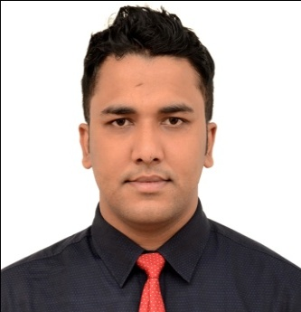
Muhammad Masrur Ahmed
CURRICULUM VITAE
C/O:Md. Rajab Ali
Vill: West Swingor(Bonbari)
P.O: Sreemangal
P. S: Sreemangal
Dist.: Moulvibazar
Email: masrurahmed36@yahoo.com
Cell: 01716429534
CAREER OBJECTIVE:
Searching for a desirable opportunity with which I will have the scope in utilizing my skills and potentiality to do something innovative for the benefit of mankind and the society as well and from which I will be able to enhance my knowledge and efficiency.
CAREER SUMMARY:

A drive to perform, patience, accepting challenging work & willingness to learn.
EDUCATION QUALIFICATION:

- M. S.S In Political Science at M. C. College, Sylhet, under National University - 2012,
Result – Second Class

- I C T Information and communications technology ) M.C College Sylhet, Result-CGPA:3.2

- B. S. S (Hon’s) in Political Science at M. C. College, Sylhet, under National University -2011,
Result – Second Class.
- H.S.C (Humanities) From Sreemangal Govt. College, Sreemangal, under Sylhet board in 2007,
Result – 3.20 (out of 5).
- S.C.C (Science) From Hooglia Hazi Moncob Ullah High School,Satgown under Sylhet board in 2005,
Result – 2.88 (out of 5)
EXPERIENCE:

Organization: Hotel Metro Internatinal, Sylhet
Position : Front office executive & Data Entry Operator
Duration : 1stJanuary, 2012 to December 2015
Major Responsibilities:
● Cash receive, ● Voucher entry, ● Patty cash maintain, ● Answer and direct phone calls., ● Write and distribute email, correspondence memos, letters, faxes and form., ● Assist in the preparation of regularly scheduled reports, ● Develop and maintain a filing system, ● Update and maintain office policies and procedures, ● Deed writing, ●Customer Relation etc.
COMPUTER SKILS:

- Operational knowledge on Windows 98/2000/NT/XP/Vista
- Completed a certificate course on MS Office Suite (MS word, Excel, Access & Power Point), E-mail
& Internet browsing.
LANGUAGE:

- Excellent command on speaking and writing in both Bangle and English.
HOBBIES:

- Reading Newspaper & Magazines.
- Reading Novels & Story Books.
- Listening Music
- Traveling
- Passionate about Cricket
PERSONAL INFORMATION:

Name : Muhammad Masrur Ahmed
Father’s Name : Muhammad Rajab Ali
Mother’s Name : Rowshanara Akhter
Date of Birth : 15th October, 1988
Nationality : Bangladeshi by birth
Sex : Male
Marital Status : Single
Religion : Muslim
Height : 5 Feet 9"
Blood Group : A+

REFERENCE:

Khalilur Rahman Masum Md.Shajahan Ali
Managing Director Managing Director
Mark Property Lt. Metro City women’s college, Sylhet
Hotel Metro International. Cell: 01715610927
Former President Sylhet Hotel &
Guest House Owners Group
Cell: 01711383091

I confirm that to the best of my knowledge, all the information given here is correct and complete.

Yours Sincerely

Muhammad Masrur Ahmed

