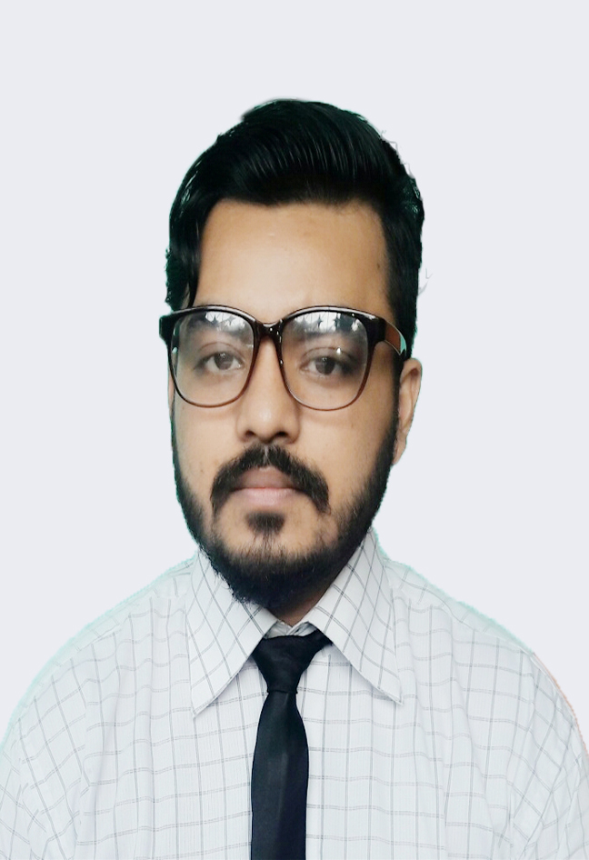
Photos

Resume

of Mustafizur Rahman

Present Address: Waves 40, Chandantula, Amberkhana, Sylhet .
Permanent Address: Vill: Kalaguja P.O: Selimgonj P.S: Jamalgonj
District: Sunamgonj.
Cell: 01751285867 / 01621694899
E-mail: mrsany.mu@gmail.com

Objective
Intended to build a long standing career relationship in the sector where I can make the best use of skills, knowledge and abilities for the ultimate benefit of the organization I work for.

Education

Name of Exam | Group/Subject | Passing Year | Board/University | G.P.A
SSC | Science | 2010 | Sylhet | 4.44
HSC | Science | 2013 | Sylhet | 3.20
B.Sc (Hon’s) | CSE | Appeared | Metropolitan University

Skills & Abilities

HTML

cSS

JAVA SCRIPT

PHP

C PROGRAM

Communication

- I can represent a team
- A good communication skill and negotiation capabilities.

Computer Skills
. Typing Speed 20-30 WPM
. Good knowledge on MS-Office
. Operating System: Windows XP, Vista, 7, 8, 10.
. Knowledge on Photoshop

Language Known
- Bengali
- English

Social Work

Surovi Somaj Kollan Somity, Sylhet. Govt. Reg: 1127/10 |25-08-2014 to presrnt
- Secretary

Human Rights watch trust of bangladesh |01-08-2017 to presrnt
- LIFE TIME MEMBER (Sylhet Division)

Hobbies
. Internet Browsing,
. Social Networking,
. Playing Cricket,
. Reading Stories.

Personal Details

Name : MUSTAFIZUR RAHMAN
Father’s Name : HABIBUR RAHMAN
Mother’s Name : MINARA BEGUM
DOB : 29TH September 1993
Gender : Male
Religion : Islam
Nationality : Bangladeshi

Reference
Name : MUSHFIQUR RAHMAN(Micky)-Ex Employee
Relationship : BROTHER
Email : mrziku.lu@gmail.com
Contact : +37256771706

Declaration
I hereby declare that the above information furnished by me is true to my best knowledge and belief

Yours Sincerely,
Mustafizur Rahman

