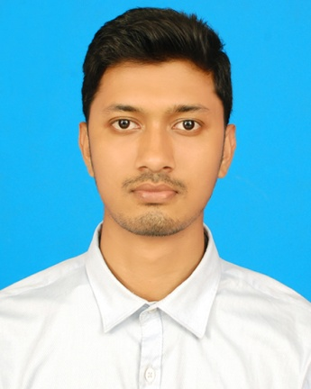  Rafiqul Islam  B.Sc. in Computer science,  Leading University, Sylhet.    ,Daptaripara, Raynogor Sylhet.  Mobile: 01776493513  Email: mrofiq44@gmail.com    *I am a recent graduate  *Strong leadership, motivational and people management skills.  *Self motivated and business attitude  *Business development, Communication and customer service.  *communication  *Ability to work under pressure | Curriculum Vitae      Networking: Router Configuration, RIP Configuration, Vlan Configuration, Lan, TroubleShooting etc.  Programming Language: C,C++ and Basic Java.  Web: Html, Css, Php, mysql.    1.BUS TICKET BOOKING ANDROID APP  2.WEB BASED-WORKFLOW MANAGEMENT SYSTEM  *Part Timer at SARABPO LLC(Data Entry,Analysis,WebSearch)  *Teaching experience at Coaching centre and as home tutor    I love cycling and playing Football.  I also enjoy Cultural activities and also love bike riding.
  Contact
  Profile
  Education
  Name of the Degree | Passing Year | Grade
  B.Sc.(CSE) | 2019 | 3.90(CGPA)
  H.S.C | 2014 | 4.60(GPA)
  S.S.C | 2012 | 5.00(GPA)
  Skills
  Project Done
  Work Experience
  Hobbies & interests
Personal Information
Name : Moha.Rafiqul Islam
Fatther’s Name : Md.Zillul Haq
Mother’s Name : Mst. Nazma Begum
Date Of Birth :20th December 1995.
Religion : Islam
Nationality :Bangladeshi.
Permanent Address : Syed Mandaruka ,Osmaninogor,Sylhet.
Present Address : Daptaripara,Raynogor,Sylhet.
Marital Status : Unmarried
Height : 6 feet 1 inch.
Weight : 67Kg
Skin Colour : Fair
Mobile : 01776493513
Email : mrofiq44@gmail.com

