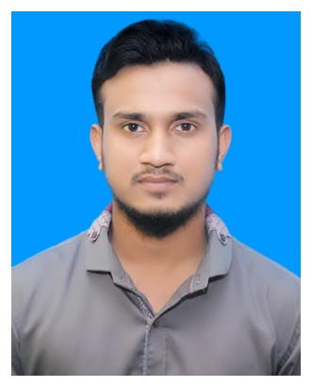

Yeamin Ahmed
144/A Shornoshikha, Kodomtoli, Sylhet
Mobile: 01738180144
E-mail: yeaminahmed10@yahoo.com

CAREER OBJECTIVE

As computer engineering is a competitive job nowadays, I always try to complete the given work in a short way and creatively.

ACADEMIC CREDENTIALS

B. Sc. (Engg.) Computer Science and Engineering
Institute : Sylhet International University
Session : Spring 2013
Year of Passing : 2017
CGPA : (Appeared)

Higher Secondary Certificate (HSC)
Board : Sylhet Board
Institute : Sylhet Govt. College, Sylhet.
Group : Science
Year of Passing : 2012
GPA : 3.50

Secondary School Certificate (SSC)
Board : Sylhet Board
Institute : Shahjalal Jamia Islamia School & College, Sylhet.
Group : Science
Year of Passing : 2010
GPA : 5.00

SKILLS & ABILITIES

- Operating Systems : Windows 98, XP, 7, 8, 10;
- Languages : C, JAVA, HTML, CSS.
- Applications : Microsoft Word, Microsoft Excel, Microsoft PowerPoint.
- Graphics Software : Adobe Photoshop.
- I am able to install any OS and able to troubleshoot software problem in computer.

EXTRA-CURRICULAR ACTIVITIES

- I am founding member of CSE Society in Sylhet International University.
- Organizer of SIU Cricket Tournament.
- My Football team participated and won runners up trophy in SIU Mini Football Cup 2016
- I have arranged many sports tournament where renowned players across the country participated.

VOLUNTARY ACTIVITY

- Certified Red Crescent First Aid Trainer.
- Government Certified Fire Service Trainer.
- I am the finance secretary of a nationally registered social welfare club named “Shornoshikha Social Welfare Committee” in WARD No. 26, Kodomtoli, Sylhet.

INTEREST & HOBBIES

- In my extra time, I generally attempt to take on any computer related things by reading various technology related articles, magazine and additionally book.
- I have likewise interesting settling any equipment issues.
- I most often help my relatives and friends by installing OS, software, setup home network and printers which certainly broaden my perception into experience.
- I additionally have a distinct fascination with photography and photograph editing by utilizing Adobe Photoshop, Adobe Lightroom and some other expert software.
- I prefer passing time with the juniors of my village.

LANGUAGE EFFICIENCY

Fluent in Reading, Speaking and Writing in English. First language Bengali. Know Arabic a little.

PERSONAL DETAILS

Father's Name | : | Abdul Haque Ana
Mother's Name | : | Dilwara Begum
Date of Birth | : | August 10, 1993
Gender | : | Male
Marital Status | : | Unmarried
Nationality | : | Bangladeshi
Religion | : | Islam
Permanent Address | : | 144/A, Shornoshikha, Kodomtoli, Sylhet.

REFERENCES
Md Khaled Hossain  Head & Assistant Professor  Department of CSE  Sylhet International University  Email: khussain@ymail.com  Mobile: 01712 219040 | Sushanta Acharjee  Assistant professor  Department of CSE  Sylhet International University  Email: sujan.a13@gmail.com  Mobile: 01911 878981

