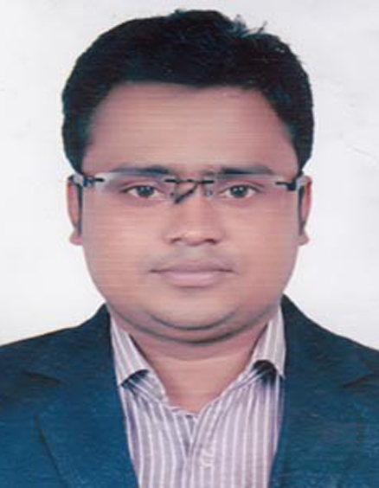
CURRICULUM VITAE
Of
Md. Mufazzal Hossain Babu
Mailing Address:
Vobanipur (Kacharipara)
Sujanagar, Pabna
Mobile No-01751-313600,

E-mail Id: mufazzal.hossain1017@gmail.com

Working Experience
- Suntacruz Denso
- 20/2 Rasulbagh, Muhakhali, Dhaka
- Designation: Technichian & Accounts
- 6 old Gabtoli, Majar Road, Dhaka
- Disle Fuel pump : I got ideas about diesel powered engine fuel pump parts from different cars. And there's also ideas about car parts. And I'm eager to take more ideas.
- Joining Date: 01/04/2014
- Regain Date: 30/06/2018
- Neptune Lefts & Scaleretore
- Motijhil, Dhaka
- Designation: Technichian
- Service & Meatiness - I learned how to do elevator work
- Joining Date: 01/11/2012
- Regain Date: 25/03/2014
- IFAD GROUP
- IFAD AUTO SERVICES LTD.
- Head Office Address: IFAD Tower,Holding No. 07,
- Tejgaon Industrial Area,Dhaka-1208,Bangladesh
- Designation: Executive – Spares Parts
- Ashok Leyland has been able to get ideas on all parts of the car. And interested in more parts knowledge.
- Joining Date: 16.05.2019 (Continuing)

.

CAREER OBJECTIVES
To work in a challenging environment with a scope of future progress, applying my academic
knowledge and working capacity. I would like to welcome the chance to work as a part of a dynamic working team where I could make a significant contribution while developing my skills yet further.

EDUCATIONAL QUALIFICATION

Diploma in Power Engineer

- Institute : Pabna Polytechnic Institute pabna.
- Group : Power Technology.
- Board : Bangladesh Technical Education Board.
- Passing Year : 2013
- Result : GPA- 3.02 (Out of 4)

Secondary School Certificate (S.S.C)
- Institute : Sujanagar Pilot High School.
- Group : General Electrical Works (SSC Vocational)
- Board : Bangladesh Technical Education Board.
- Passing Year : 2008
- Result : GPA- 3.91 (Out of 5)

PERSONAL INFORMATION

- Name : Md. Mufazzal Hossain Babu
- Father’s Name : Md. Mojammel Hoque Chunnu
- Mother’s Name : Most. Sahanaj Begum
- Present Address : 43 Darusalam, Mirpur, Dhaka
- Permanent Address : Vill-Vobanipur, P.O-Sujanagar
P.S-Sujanagar, Dist-Pabna
- Date of Birth : 21/06/1993
- Nationality : Bangladeshi (By Birth)
- Religion : Islam
- Sex : Male
- Marital Status : Married
- Height : 5′-5″
- Weight : 63 KG
- Blood Group : AB⁺(ve)
- National ID No. : 19937628303000017

Communication skill

- English : Fluent in writing & speaking
- Bangla : Mother language

Computer Skill

- Computer Office Course. Ms- Word, Ms- Excel, Ms- Access, Power Point & Internet.

Reference:
1. Md Kamruzzaman
Manegment Trainee (HR & Admin)
City Group
Mob 01748101514

Declaration

I hereby declare that the above particulars are true to the best my knowledge and belief and I am strong in body and mind, hard working and ambitions to be successful in life. I capable to adjust of all people at any circumstance and have a great interest for team work.

Signature

Md. Mufazzal Hossain Babu

