Present Address

Name : Md. Ashraful Islam
House No. : 35/1 Karipara
ZIP Code : 3100
District : Sylhet
E-mail :shajol39 @gmail.com
Cell : +8801647094078

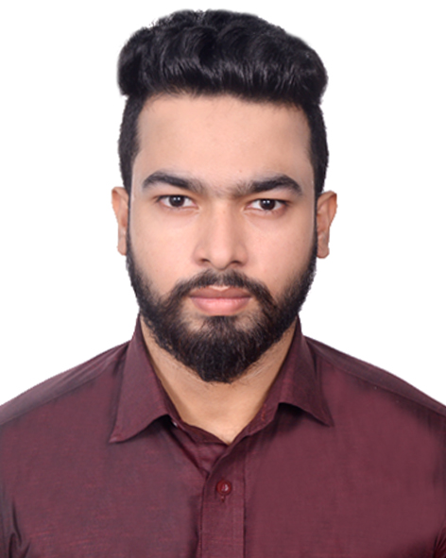

Academic Qualification

Exam | Group | Result | GPA | Institute | Passing Year
SSC | Commerce | 4.69 | 5 | Rifles public school,Sylhet | 2010
Diploma | Electro-Medical | 2.71 | 4 | Sylhet Polytechnic Institute | 2015
BSC | EEE | 2.86 | 4 | Metropolitan University, Sylhet | 2019

Computer Literacy

- Able to handle computer office applications (Microsoft Word, Excel, Power Point and Access).
- Internet Browsing & E-mail Usage.

Language Skill

- Medium of Instruction in the Departmental Study in English.
- Excellent Listening, Reading, Writing and Spoken skill in both, English and Bangla language.
- Was a member of English Language Club in high school.

Interests & Activities

I love to be engaged with social welfare activities, reading newspapers, doing researches with newly emerged topics, listening to music, playing indoor games and I am highly interested in teaching profession & travelling.

Personal Information

Name : Md. Ashraful Islam
Father’s Name : Md Abdul Khalek
Mother’s Name : Mst. Layla Akther
Date of Birth : 18th September, 1995
Sex : Male
Blood Group : O+
Marital Status : Unmarried
Religion : Islam
Nationality : Bangladeshi (By Birth)
Mobile No : +8801647094078

Permanent Address

Village: Ukilbari Sarak, U/P:Barishal Sadar, P.O:Rupatali, District: Barishal

Commitment
I am to a certain extent is incredibly confident that with my educational qualifications, acquired knowledge, enthusiasm and various dimensional experiences, I would be able to perform all the duties and responsibilities assigned to me in connection with my job.

Announcement
I do hereby declare that, the particulars provided here are true and no misinformation is given. I authorize the respective authority to verify the information provided in this CV.

Md. Ashraful Islam

