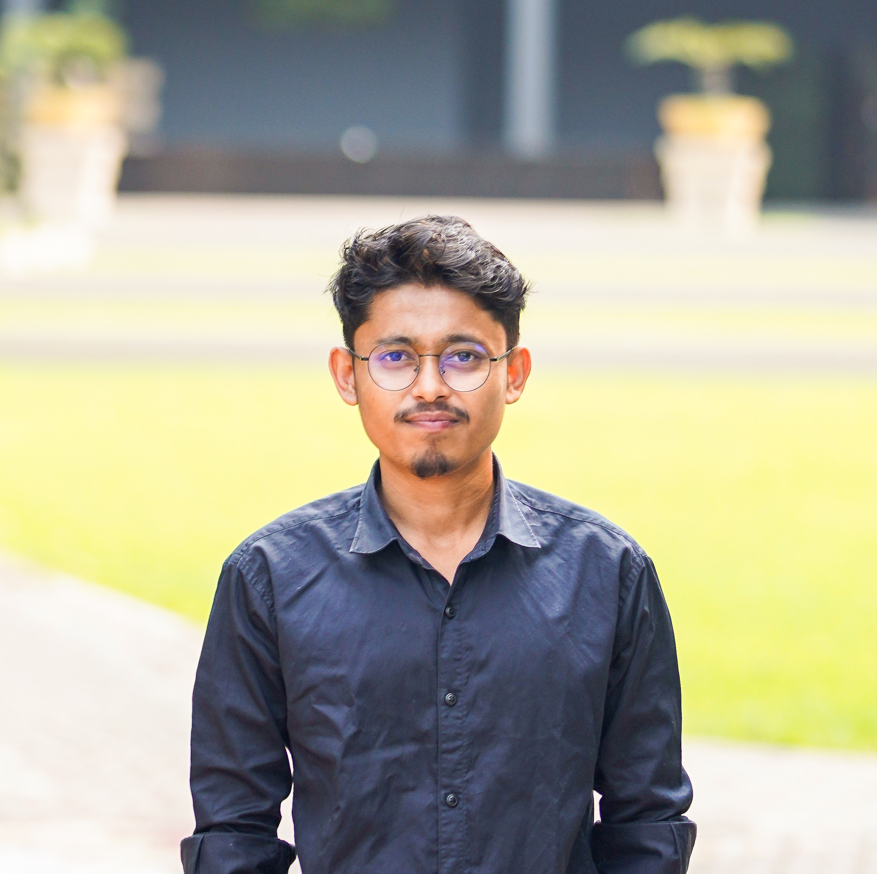
Institute : Wedlock Heritage
Possition : Cinematographer & Chief Editor
Experience : 3 years
PROFESSIONAL EXPERIENCE

DIPLOMAS Y HOBBIES

Formaciones : Diplomados, Congresos, xxxxxxxxxx xxxxxx xxxxxxxxx xxxxxxxxxxxxxxxxx
Hobbies: xxxxxxxxxxxxxxxxxxxxxxxxxxxxxx


ATIKUR RAHMAN

EDUCATION

DIGITAL CONTENT CREATOR

University : National University
Subject : Sociology
Session : 2018-2019
Result/CGPA : 2.59
CONTACT

01709041381 / 01648752174


atik53820@gmail.com


Jalalabadh, Ambarkhana, Sylhet

PERSONAL INFORMATION
LANGUAGE PROFICIENCY
Have a good writing and speaking command in Bangla & English

Name : Atikur Rahman
Father’s Name : Md. Riaz Miah
Mother’s Name : Khaleda Akther
Date of Birth : 27/12/1998
Gender : Male
Religion : Islam
Marital Status : Unmarried
Nationality : Bangladeshi
National ID No. : 8707728864

As a Content Creator with over 5 years of experience in delivering impactful and thought-provoking stories, I am passionate about cinematography & editing. I am committed to producing high-quality, accurate, and engaging content that story, educates, and inspires audience. Seeking a challenging role in a reputable media organization where I can utilize my skills in research, writing, and storytelling to contribute to the organization's success while advancing my career as a content creator.
I certify that all information stated in this resume is true and complete to the best of my knowledge. I authorize the respective authority to verify information provided in this resume.

CERTIFICATION
- Filmmaking
- Travelling
- Sports
- Contemporary Art and Sociology
- Hiking & Outdoor Exploration
INTERESTS
Lightroom PC

Photoshop PS

Davinci Resolve

Adobe Premier Pro

TOOLS
VFX Creation

Cinematography

Editing

Graphics Design

Photography

SKILLS
SKILLS
©AZURIUS - My-resume-templates.com

