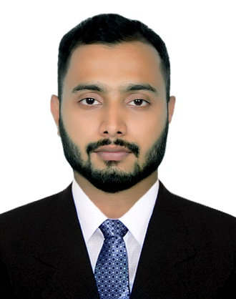
ARAFAT HUSSAIN CHOWDHURY (JON)
Contact No: 01741161380
Email: jonchowdhury2015@gmail.com

Career Objective:
To perform in a challenging position which will provide me an opportunity to utilize and develop my creativity, competency as per my academic knowledge.

Profile:
I am a self motivated person and believe in hard work, integrity, perseverance and dedication towards the work on my hard advancement through explanation to newly acquired knowledge in future.

1. Educational Qualification’s:

A. B.A in English  Name of University  Year of Completion  Major Subjects  Result | : Sylhet International University  : 2017  : English language communication and literature  : 3.05 Out of 4.00
B. Higher Secondary Certificate (H.S.C.)  Name of College  Year of Completion  Board  Group  Result  C. Secondary School Certificate (S.S.C)  Name of School  Year of Completion  Board  Group  Result | : Syed Nabib Ali College, Beanibazar, Sylhet  : 2012  : Sylhet.  : Commerce  : 3.60 Out of 5.00  : D.M High School, Beanibazar, Sylhet  : 2010  : Sylhet  : Science  : 3.25 Out of 5.00

2. LANGUAGE PROFICIENCY:
Good communication abilities in Bengali and English both verbal and Writing.

3. INTEREST AND ACTIVITIES:
Traveling, Sports, Public relation, Movies, Music etc.

4. Computer Knowledge:
Ms Word, Ms Access, Ms Excel, Ms Power Point, Internet Browsing etc.

Personal Details:

nAME  Father’s Name  Mother’s Name  Permanent Address  Present Address  Sex  Date of Birth  Nationality  Religion  Height  Blood Group  Marital Status  NID  Mobile Number  Email | : Arafat Hussain Chowdhury (Jon)  : Shahjan Hussain Chowdhury  : Habiba Akter Chowdhury  : Vill: Alinogor, P.O: Alinogor  P.S: Beanibazar, Dist: Sylhet  : 192 aikkotan,West pirmoholla, Sylhet - 3100.  : Male  :18th May 1993  : Bangladeshi by birth  : Muslim  : 6feet  : O-ve  : Unmarried  : 19939111711000209  : +8801741161380  : jonchowdhury2015@gmail.com

Reference:

- M.Shahadat Hussain Chowdhury.
Senior Manager, CTSL.
Chittagong, Bangladesh.
Mobile: +8801937-400489

2) Prodhan Mahbub Ibna Seraj
Assistant Professor
Head of the Department
Department of English
Sylhet International University
Mobile: +8801727-191342

I do hereby declare that the above information is true and correct to the best of my knowledge.

Signature & Date

---------------------------------------------------------------
Arafat Hussain Chowdhury

