Curriculum Vitae
Of
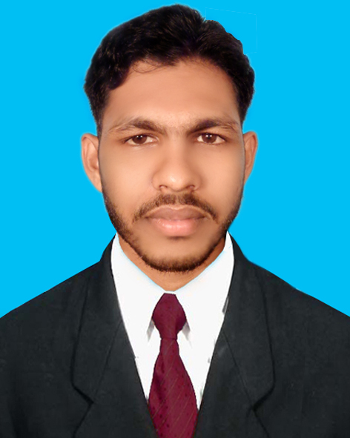
MD.Sohag Mia

Mailing Address:
Md. Sohag Mia
C/O : Md.Shahjalal Mia
Address : Vill.Kupdhon, P.O:Kamarhat,p.s:Patharghata,Dist:Barguna.
Current Location : 44/N,Zigatala New Road,Khan
Buliding,Danmondi,Dhaka
Mobile : +8801729477301
E-mail :sohagsm77@gmail.com

Career Objective:

As I love things about business, I want to explore my career through it. I want to gather more knowledge as I can and explore my creativity in this competing world of business and participate in the development of my people and my country.

Academic Qualification:
Degree | Concentration/Major | Institute | Result(GPA/CGPA) | Passing Year | Duration
MBA | Accounting | Barguna Govt. college in National University. | CGPA-2.84out of 4 | 2014 | One Years
BBA | Accounting | Barguna Govt. college in National University. | CGPA-2.59out of 4 | 2013 | 4 Years
HSC | Business Studies | Patharghata College in Board of Barisal. | GPA-3.50 out of 5 | 2009 | Two Years
SSC | Business Studies | Rupdhan Bandar amiria secondary Schoolin Board of Barisal. | GPA-2.88out of 5 | 2007 | Ten Years

Research Work:
- An Analysis on the effect of Resurech Programs and advertisement on village people
- Report on“Financial Performance Analysis of ResoureDeplovmentFundation ( RDF) company Of Bangladesh

Computer Skill:Have a primary and working knowledge about-
- Microsoft office (MSWord, MS power point, MS excel,)
- E-mail communication,
- Internet browsing.
- Hardware Management and troubleshooting.
Successfully accomplished the course of “Computer Fundamentals” and obtained .

Hobbies: Reading Books, Traveling, & playing games

Personal Information: Name:MD Sohag Mia
Father’s name : MD.Shahajal Mia
Mother’s Name : Nasima Begum
Date of Birth : 4th July, 1992
Nationality : Bangladeshi (by Birth)
Religion : Islam
Marital Status : Single
Sex : Male
Height : 5 feet 4 inch
Weight : 50 kg
Permanent Address :Vill.Kupdhon, P.O:Kamarhat,p.s:Patharghata,Dist: Barguna
Current Location : 44/N,Zigatala New Road,Khan
Buliding,Danmondi,Dhaka

Declaration of Authenticity:
I do hereby declare that all information here is true of my knowledge. If required and where applicable, this document can be supported by appropriate authentic certificates/Papers.

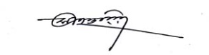

MD Sohag Mia
Date:

