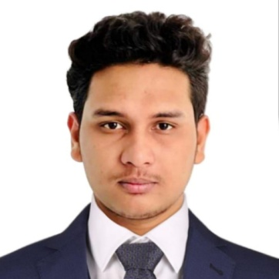
Resume
of
Alif Mehedi Niaz

E-mail: alif47-941@diu.edu.bd.
Mobile No :01724326427,01609223625

Key Qualification: I obtained my degree in Bachelor of science in civil Engineering from Daffodil International University (DIU), Dhaka. My Professional Experience 2 years.
I want to contribute my expertise for the growth of the organization.
Personal Information:

Name : Alif Mehedi Niaz
Father’s Name : M. A. Rafique
Project Manager ,UPSL
United Group.
Mother’s Name : Nazmunnaher (House Wife)

Permanent Address : Vill: Kalabadha, Post: Durmut,
P.S: Melandaha, Dist: Jamalpur.
Present Address : Dewanpara, Chairman Mansion, 3rd Floor East Unit (Rent), P.S: Jamalpur Sadar, Dist: Jamalpur.
Date of Birth : 1st December 2000
Gender : Male
Marital Status : Single
Blood Group : A+
Religion : Islam
Nationality : Bangladeshi (By Birth)
Height : 5'- 7''

Educational Qualification:

Bachelor of Science in–Civil-Engineering
Daffodil International University, Dhaka, Bangladesh
CGPA : 3.00 (Out of 4.00)
Passing Year : 2023

Firoza Bashar Ideal College, Dhaka.

Higher Secondary School Certificate

Kalabadha Multilateral High School, Melandah, Jamalpur.

Secondary School Certificate.

Name Of The Company: Lasaco Devolopment,Bosundhora city,Dhaka
Experience : 6 month.
POSITION:Site Engineer.

Name Of The Company: United Group.

Experience: 1 year 8 Months.

Project: United LPG Rupganj, Narayanganj.

Position: Trainee Engineer (Civil).

Name Of The Company:Heaven 24,Bokultala,Jamalpur sadar.
Experience: 3 Months contractual.

Responsibility: Supervision of construction works , Spherical tank base and short column, Cast in situ pile, LPG filling hall, Fire tank macadam base, Utility building up to 2nd floor, Boundary wall, Retaining wall, Bill checking, BOQ making, Estimating etc.

Computer Literacy: MS Word, Excel, Internet Browsing and AUTOCAD Design(2D) .

Language Proficiency: Fluent “Communication Skill” on Speaking and writing
well in Bengali & English.

Date:.14-01-2026. ALIF MEHEDI NIAZ (Signature )

