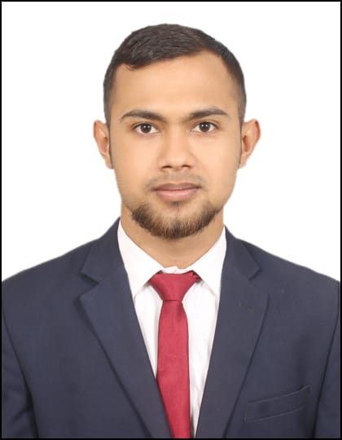 |  | NIKESH NAIYANG  Humanitarian & social welfare
Profile  An adaptable, conscientious and enthusiastic care worker with experience in providing a professional care service to welfare services. A proven ability to deal with physically and emotionally demanding care needy/client and to successfully help them to retain, regain and develop skills needed for independent living. Now looking for a new and challenging care worker position with and reputable company or foundations.  Contact  Nizpat Toasihati Jaintapur,  Sylhet Bangladesh  PHONE:  +880177272292  EMAIL:  nikeshnayang@gmail.com  Hobbies  Playing football  Playing Badminton |  | EDUCATION  MASTERS of SOCIAL WORK 2018-2020  Banaras Hindu University, Varanasi, Uttar Pradesh, India first division  B A SOCIOLOGY 2015-2018  Banaras Hindu University, Varanasi, Uttar Pradesh, India first division  INTERMEDIATTE 2012-2014  Jalalabad Cantonment Public School & Collage, Sylhet A+  HIGH SCHOOL 2010  Jointapur Government High School, Jointapur A  WORK EXPERIENCE  Women Welfare Department Varanasi UP (ICDS) 29–01-2019 to 02-04-2019  Functions:  To improve the nutritional and health status of children in the age-group 0-6 years;  To lay the foundation for proper psychological, physical and social development of the child;  To reduce the incidence of mortality, morbidity, malnutrition and school dropout;  To achieve effective co-ordination of policy and implementation amongst the various departments to promote child development;  To enhance the capability of the mother to look after the normal health and nutritional needs of the child through proper nutrition and health education.  Skills  - Quick learner  - Inquisitive  - Ability to carryout  - Instruction  - Innovative  - Good communicator  - interpersonal skills  Sports activities:  - Captain of University Football team  - Winner of University Badminton Championship  Winner

