Curriculum Vitae

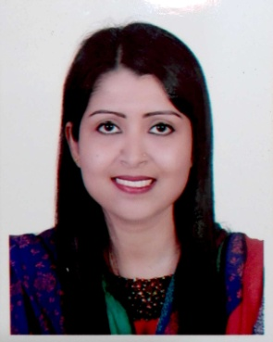

Nahida Akhtar Choudhury

Nurani-65/6, Bonkolapara,
Subidbazar, Sylhet.
Mobile: +8801746467392
E-mail : nahidachy2015@gmail.com

Career Objective
To develop a shiny career, where I will have the scope to utilize myself potentially. Adaptability and skills to do something innovative and opportunity for long term career growth and advancement.

ACADEMIC Qualifications

Degree | Group/Department | Board/University | Result | Year
B.B.A. | Business Administration | Leading University, Sylhet | 3.78 | 2015
H.S.C. | Business Studies | Sylhet Board | 4.00 | 2006
S.S.C. | Business Studies | Sylhet Board | 4.69 | 2004

Experience

- Worked as a internee at Trust Bank Limited
- Worked as a Brand Promoter at Robi Axiata Limited.
- Worked as a class teacher at Banyan British School.

Extracurricular ACTIVITIES

- Member of Leading University social service Club.
- Volunteer member of Jaago Foundation Bangladesh.
- Member of Bangladesh Scout.

computer and communication skills

- Sound in MS Office (Word, Excel, Access and Power Point) and have good Knowledge about Internet,Operating System)
- Bangla is Mother Language and fluent in speaking and writing in English as second language.

personal details

Name :Nahida Akhtar Choudhury
Father’s Name : Late Altaf Uddin Choudhury
Mother’s Name :Fathema Akhtar Choudhury
Permanent Address :Vill:-Kaudia, P.O:-Kaudia, P.S:-Beanibazar
Dist:-Sylhet-3100
Mailing Address : Nurani-65/6, Bonkolapara, Subidbazar,Sylhet.
Date of Birth : 16th July, 1987
Nationality : Bangladeshi
Religion : Islam
Height : 5’6’’
Gender : Female
Marital Status : Single
National Id No : 9111711991652

References

Md. Ismail Hossain  Manager  WIC  Customer Experience,  Market Operation Division,  Robi Axiata Limited,  117-Azadi,Mirboxtula,  Sylhet.  Mob: +88 01819210363 | Dr Nargis Akhter Choudhury  MBBS, MD (BSMMU),  Medicine & Diabetes Specialist,  250 Beded Hospital,  Moulovibazar Sador, Moulovibazar,  Sylhet.  Mob: +88 01619048084

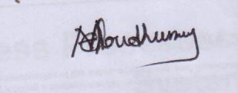
……………………..
Nahida Akhtar Choudhury

