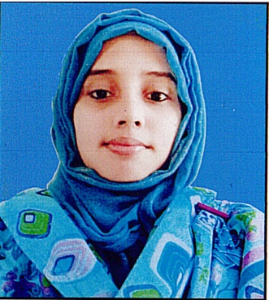
Najmun Nahar Rony

House no: 47, Road no: 07,
Housing State, Ambarkhana, Sylhet.
Mobile: 01785-053379
Email: najmunrony202@gmail.com

About Me
My vision is to ascertain a position by creating values both in the customer and company end by using my full expertise on communication, networking & building strong relationship with the stakeholders in a friendly environment which demands hard work, innovativeness, technological knowledge but offers opportunity to learn something new.
Education
Master’s Business Administration
2nd Semester in progress
Major in Finance & Banking
Sylhet International University
Sylhet

Bachelor, Business Administration
Graduated, August, 2017
CGPA: 3.62
Scale: 4.00
Major in Finance & Banking
Sylhet International University
Sylhet

Higher Secondary School certificate (HSC)
Passed, July 2011
GPA: 3.80
Scale: 5.00
Science
Hafsa Mazumder Mohila Degree College,
Zakigonj, Sylhet
National Curriculum, Sylhet Board

Secondary School Certificate (SSC)
Passed, June 2009
GPA: 4.81
Scale: 5.00
Science
Gonipur Kamalgonj High School,
Zakigonj, Sylhet
National Curriculum, Sylhet Board

Working & Organizational experience
Worked for three months as an intern in Bangladesh Krishi Bank.
- Internship Report on “Credit Risk Management of Bangladesh Krishi Bank”: A study on Ambarkhana Branch, Sylhet.
Member of Quantum Foundation
Volunteer of Female Welfare Association
Job Responsibility
Helping the poor women and the disabled children
Provided free wealth care to poor women
Provided awareness and facilitation on family planning
Volunteer of Rural 2 Urban Social Organization
Job Responsibility
Helping to common people on the day of any disaster or crises.
Provided the treatment & medicine to poor people.
Make people aware about gender discrimination & child labor.

Achievements:
Participated 1st “English Olympiad of Bangladesh”, 2017, English Competition organized by “WOC”
Computer Literacy:
Ms Office (Better in word, excel, power pint)

Language Proficiency:
Proficiency with reading, writing and speaking of both English and Bangla.

Personal Interests:
Reading Books , reading newspaper, watching movie, Traveling , writing.

Personal Details:
Nationality: Bangladeshi (By Birth)
Marital Status: Single
National ID: 19939119476000005
Father’s name: Md. Abdul Jabbar
Mother’s Name: Hasna Begum
Sex: Female
Date of birth: 05 February, 1993
Permanent Address: Vill: Shohidabad, P.O: Gongajol, Upazila: Zakigonj, Dist: Sylhet.

Reference:
Abu Sayed Muhammad Abdullah
Professor and Head
Dept. of Business Administration
Sylhet International University, Sylhet
Cellular: 01751232222
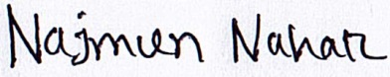

Najmun Nahar Rony
Sylhet 29th November 2018

Abdullah-Al-Mamun
Deputy Director
Bangladesh Rural Development Training Institute (BRDTI)
Kadimnagar, Sylhet
Cellular: 01938774714
Email: rkmbrdti@yahoo.com

