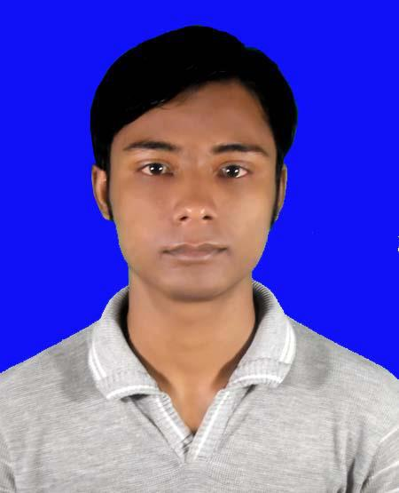
RESUME
OF
MD: NASIM UDDIN

CARRIER OBJECTIVE ZZZZZZZZZZZZZZZZZZZ Z

I want to build up my carrier in sector where I can explore myself. I want to have extensive responsibilities and the opportunity to contribute to the organization and want to have the opportunity to develop myself to strengthen the organize.

EDUCATIONAL QUALIFICATION

Bachelor of Business Study (B.B.S) Degree

- Institution : Natore City College
- Group : B.B.S
- Result : 3nd Class
- Passing Year : 2015

Higher Secondary Certificate (H.S.C)

- Institution : Bagatipara Technical And Business Management Institutions, Natore
- Result : GPA- 4.69 (Out of 5)
- Group : Business Studies
- Year of passing : 2012
- Board : Rajshahi

Secondary School Certificate (S.S.C)

- Institution : Laxmanhati High School,Bagatipar, Natore
- Result : GPA-3.33 (Out of 5)
- Group : Business Studies
- Year of passing : 2010
- Board : Rajshahi

,

COMPUTER LITERACY C

- Operation Systems: MS DOS, Windows 98Windows XP
- Application Software: MS Office (Word, Excel, Access, Power Point& Internet Browsing)

LANGUAGE PROFICIENCY ZZZ ZZ ZZZZZZZZZ

- Bengali (Excellent in listening, reading, writing & speaking)
- English (Good in listening, reading, speaking & writing)

HOBBIES & INTERST ZZ ZZ Z Z ZZ ZZZZZZZ

- Traveling
- Reading Books
- Listening Music
- Watching Movies etc

PERSONAL PROFILE ZZZZZZ ZZZ

- Name : Md. Nasim Uddin
- Father’s Name : Md. Meher Ali
- Mother’s Name : Most. Nasira Begum
- Nationality : Bangladeshi (By Birth)
- Marital Status : Un-married.
- Date of Birth : 30/10/1995.
- Religion : Islam.
- Sex : Male.
- Blood Group : B+
- Height : 5”6
- Permanent Address : Vill : Thangamara Post : Nazirpur,
P.S: Bagatipara, District: Natore.
- Mailing Address : Vill : Thangamara Post : Nazirpur,
P.S: Bagatipara, District: Natore.
- National ID No : 19956910919000188
- Mobile No : +8801767-364692
- E-mail : nasim.tvc@gmail.com

I,am Md. Nasim Uddin do hereby declare that the particulars furnished above are accurate and true to my knowledge and belief.

Your Truly,

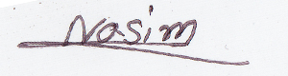

(Nasim Uddin)

Date: 11/282018.

