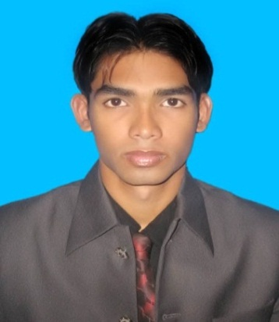
Resume of
Md. Abu Nawshad
06,Khan Monjil,
Nurbag,Nurbag mosque Road,
Dhonia,Jatrabari,
Dhaka-1236,
Mobile: - +8801924468385,
E-mail:- nawshad4232@gmail.com
Objectives:

To obtain applicable position in a well-reputed company requiring an environment with the opportunity of self-improvement in both individual and group based work that will ultimately lead to the future development of the company.
Experiences:
I worked at FM institute at Jatrabari branch as a manager for three years from 2012 to 2015.
At present I have been working at Corona Group as an executive since May the 1st 2017.

Professional Skills :

- Office Management
Microsoft Word,
Microsoft Excel, Microsoft Access
Microsoft power point, Internet.

Communication Skill:

- Bangla :Good proficiency in both written & spoken
- English :Good proficiency in both written & spoken
Academic Profile:

M. B. A.(Master’s) : Bangladesh Islami University
Department of Business Administration
Appeared (out of 4.00)

B. B. A.(Hon’s) : Bangladesh Islami University
Department of Business Administration
2.97(out of 4.00)

H.S.C. : Dania College
Board: Dhaka
Group: Science
Year: 2008
G.P.A- 3.40 out of (5.00)

S.S.C. : Sundalpur High School
Board: Comilla
Group: Science
Year: 2005
G.P.A- 3.88 out of (5.00)

Personal Information:

  - Father’s Name :Md. Hanif
  - Mother’s Name : Nazma Khanam
  - Gender : Male
  - Religion : Islam
  - Nationality : Bangladeshi (by Birth)
  - Marital Status : Single
  - Date of Birth :25/03/1990
  - Blood Group : O+
  - National ID Card No : 19902612935000800
  - Address : Present Address Permanent Address
06,Khan Monjil Vill-Uttar Bazarkhola
Nurbag,Nurbag mosque Post-Sri Rayer Char
Road,Dhonia,Jatrabari, PS- Daudkandi
Dhaka,1236 District-Comilla
Reference:

Md. ShahrearRizvi
Planning Executive,
Department of Planning & Engineering,
Square Textile, Bhaluka, Mymensingh
Mobile:01720530454
Md. Rafiqul Islam,
District Commandant(Sirajganj),
Bangladesh Ansar& VDP,
Mobile-01612403399,
email: rafiqmis@gmail.com

To certify that all information stated in this resume is true and complete to the best of my knowledge.

Applicant :

Md. Abu Nawshad

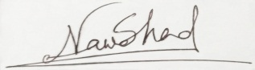

Date : The 13th September, 2018.

