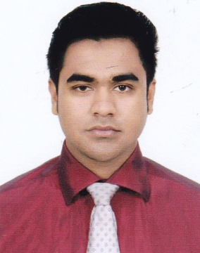

Resume of

Md.Nazim Uddin

Contact Address:
Md.Nazim Uddin
Choyon 27, chondontula,Amborkhana,Sylhet
Mobile: 01779-777775
Email:aldinnazim26@gmail.com

Career Objective:
Having the intention to work honesty sincerety, to grow and eventually take greater responsibilities and to face the challenge of the time and to gain skills successful career.

Educational Background:

Bachelor of Business Administration(B.B.A Hon's)
Session :2015-16 (4th year running)
Subject : Accounting
Institution : Modan Mohan University College,Sylhet
University : National University

Higher Secondary Certificate(H.S.C)
Institution : Jalalabad Cantonment Public School & College, Sylhet
Passing Year : 2015
Group : Business Studies
Board : Sylhet
Result :GPA-5.00

Secondary School Certificate(S.S.C)
Institution : Govt. Jubilee High School ,Sunamganj
Passing Year : 2013
Group :Business Studies
Board : Sylhet
Result : GPA-4.75

Language Proficiency:
- Bengali: Excellent in speaking, reading and writing
- English: Excellent in speaking, reading and writing

Computer Skills:
- 6 months basic computer course trained from Sylhet govt. TTC
- MS. Office programme
- Internet browsing

Experience:

1.I worked at Spark Gear (kumarpara branch) for Ramadan package.
Post: Sales associate
2. I have 3 months experience as a BP at samsung brand shop.
Tanim telecom, Sunamganj.
3.I am worked as a teacher at Brilliance Academic Care. (Subject: Accounting, Banking & Finance)
16/4, Antaranga,Electric Supply Road, North Kazitula, Sylhet-3100

Interest:
Reading novel and Humorous Story, Traveling, Watching Movies, Enjoying Music and Sports

Strength:
- Hard working
- Self-motivated, Enthusiastic and Punctual
- Dynamic and creative in thinking
- Sense of good organizational behavior

Personal Details:
Name :Md.Nazim uddin
Father’s Name :Md.Sundar Ali
Mother’s Name :Mst.Fatema Khatun
Date of Birth :12/07/1997
Nationality :Bangladeshi by Birth
Blood Group :o+(ve)
Marital Status :Single
Permanent address : Vill.Islampur
: P.O. Ambari Bazar
: P.S. Duara Bazar
: District. Sunamganj

I certify that all information stated in this resume is true and complete to the best of my knowledge. I authorize the respective authority to verify the information provided in this resume.

Signature

....................................
(Md. Nazim Uddin)

Date:

