Nazmuzzaman Sunjin
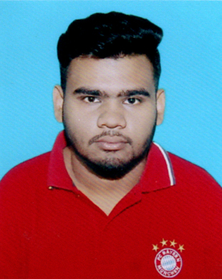

Address:50, Arju Villa, Nobab Road, Sylhet, Bangladesh
Mobile: +8801616611898
E-mail: nzsunjin7@gmail.com

Educational Qualifications

Bachelor of Business Administration (BBA)
Institution Name : Metropolitan University, Sylhet
Department : Department of Business Administration
Passing Year : Running

Higher Secondary Certificate (HSC)
Institution Name : Sylhet Commerce College, Sylhet.
Department : Commerce
GPA : 4.50 out of 5.00
Board : Sylhet
Passing Year : 2016

Secondary School Certificate (SSC)
Institution Name : Osmani Medical High School and College, Sylhet.
Department : Commerce
GPA : 3.75 out of 5.00
Board : Sylhet
Passing Year : 2014

Key Qualifications

- Self-motivated, persistent and having a good convincing power.
- Excellent at interpersonal and communication skill.
- Warm, friendly and have the ability to easily interact with people at all levels.

Computer Skills

- Operating System : Windows (XP, Vista, 07, 10)
- Application Programs : MS Word, MS Excel, MS PowerPoint.

Job Experience

- Part time job at Mega Shop

Co-curricular Activities

- Arranged various local social, cultural and welfare events.

Language Proficiency

- Have a good command in English, Bengali and Hindi both in written and verbal.

Strengths

- Hard working and coping with any circumstances.
- Have good analytical & judgmental skills
- Patient and self-motivated.

Personal Details

Name : Nazmuzzaman Sunjin
Father's Name : Abdur Razzak
Mother's Name : Nasima Razzak
Date of Birth : 11 August 1996
Nationality : Bangladeshi
Blood Group : O+
Gender : Male
Marital Status : Single
Religion : Islam
Permanent Address : 50, Arju Villa, Nobab Road, Sylhet, Bangladesh
Contact Number : +8801798-026768
E-mail address : nzsunjin7@gmail.com

I do hereby declare that particulars provided in the resume are true to the best of my knowledge and belief.



……………………
Nazmuzzaman Sunjin

