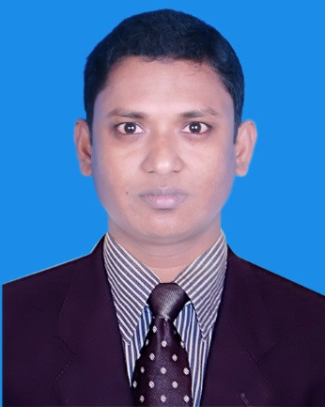
Curriculum Vitae(CV)
Md. Nazrul Islam
Mobile No: 01744-528707
E-mail: nazrulislam528707@gmail.com
Career Object:
Intend to work in a challenging and competitive environment, where the dignity of
work provides job satisfaction and the place of work provides potential avenues for
capitalizing growing and flourishing insights.
Experience:
I am working under Accounts & Finance of
 Golden Harvest Limited
Designation: Accounts officer, from 01 june, 2016 to till now.

Educational Attainments:
Masters of Business Studies (M.B.S )
Institute name : M M College,Jessore
Under of University : National University.
Discipline : Management
Year of Session : 2012-2013
Result : Second Class
Bachelor of Business Studies (B.B.S Hon’s 4 Years)
Institute name : Narail Govt. Victoria Collage, Narail.
Under of University : National University.
Discipline : Management
Year of Session : 2012
Result : Second Class
Higher Secondary Certificate (H.S.C)
Institute name : Lohagara Adarsha Collage, Lohagara.
Board : Jessore Board.
Group : Business Studies.
Year of Session : 2008
Result : 3.90
Secondary School Certificate (S.S.C)
Institute name :L,S,J,N, Union Unisttution.
Board : Jessore Board.
Group : Business Studies.
Year of Session : 2006
Result : 3.63

Computer Knowledge:
Office program : MS Word, MS Excel, MS Access.
Internet : Internet Browsing
Operating System : Windows 7, Windows 10, Professional
Skills Strength:
Skill: Strength:
Conversant With various accounting system; Honest, dedicated and Responsible
Strong negotiation skill;Strong analytical ability.
Strong at Contract Management,Positively re act to the changes and
Active team player;face constructive challenges.

Personal Information:
Name : Md.Nazrul Islam
Father’ s Name : Md.Golamrasul molla
Mother’s Name : Sakiran Begum
Date of Birth : 25 September 1990.
Nationality : Bangladeshi
Religion : Islam
Marital Status : Married
Home District : Narail
Sex : Male
Blood Group :O+

Present Address : 358/1 Modhuebag ,Mughbazar, Dhaka-1000
Permanent Address
Village : Sultia.
Post : N.S. Khola
P.S : Lohagara
Dist : Narail


--------------------------
(Signature)
(Md. Nazrul Islam)
Date:-17/10/2018

