MD.FIROZ AHMMED
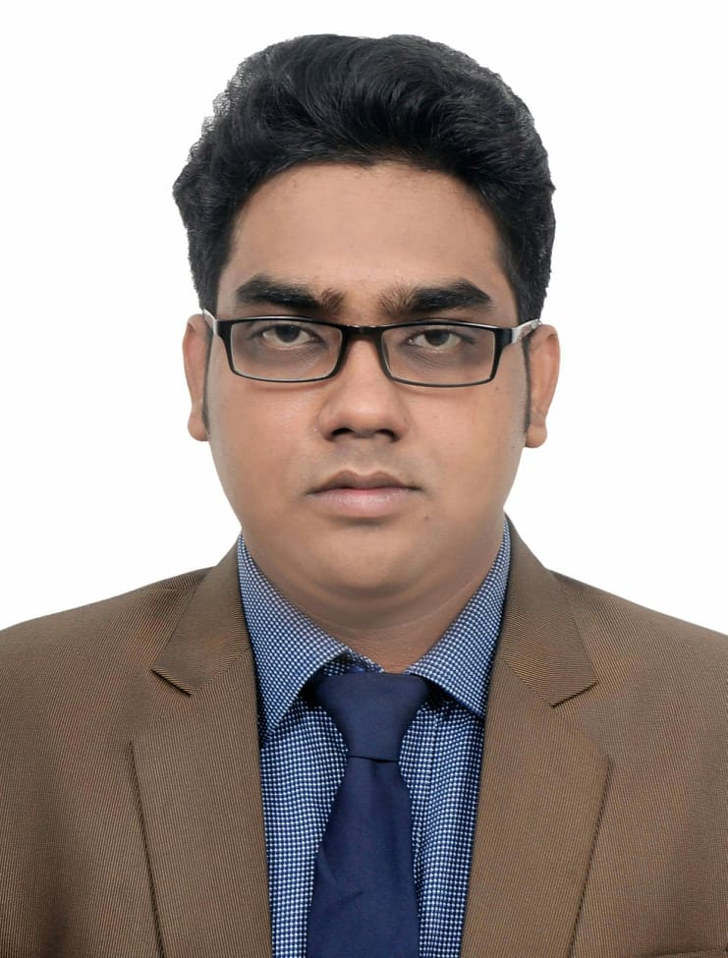

House # 222/A,Road # 2
West Agargaon,Dhaka-1207,Bangladesh
Contact No:01786-810883
E-mail: ahmmedfiroz1996@gmail.com

CAREER OBJECTIVE:

A responsible position providing for career growth, utilizing innovative skills, compatibility with others and educational experience.Desire to contribute effectively through facing new challenging responsibilities and work independently in an environment where professionalism & responsibility are of prime concern.

KEY QUALITIES:

- Able to work under pressure.
- Have a good inter-personal communication skill.
- Analytical ability.

EDUCATIONAL QUALIFICATION:

Exam Title | Board/University | Passing Year | Duration Year | Result
B.Sc. in EEE | Daffodil International University | 2019 | 4 | 3.03
HSC(Science) | Sirajganj Police Lines School & College | 2014 | 2 | 4.10
SSC(Science) | Momena Ali Biggan School | 2012 | - | 4.63
LANGUAGE PROFIENCY:
Language Speaking Reading Writing
- Bangla Excellent Excellent Excellent
- English Excellent Excellent Excellent

COMPUTER SKILLS:
- EEE related software : MATLAB R2010a,PSpice,EMU8086
- Office : Microsoft Word, Excel, Power-Point
- Graphics design : Photoshop 9.0 CS, Illustrator 8
- Internet : E-mail, Browsing, Networking

ACTIVITIES AND INTERESTS:
- Like to research and Project
- Reading novel related books to gather knowledge
- Internet Browsing
- Electrical & Electronics Engineering related books
- Travelling
- Poem reading
- Newspapers
- Singing
- Football & Cricket
PERSONAL DETAILS:
Name : Md. Firoz Ahmmed
Father`s Name : Md. Saiful Islam
Mother`s Name : Mst. Ferduisy Begum
Date of Birth : 01 January 1996
Age : 23 Years
Present Address : 222/A, West Agargaon, Dhaka-1207
Permanent Address : Vill: Tarash Dokkhin Para, P.O: Tarash,
Thana: Tarash, Dist:Sirajganj
Nationality : Bangladeshi
Gender : Male
Marital Status : Unmarried
Religion : Islam
Blood Group : AB+ve
Height : 5`-5.5``
Weight : 69 kg

CERTIFICATION:
I,the undersigned, certify that according to the best of my knowledge that belief, this resume correctly describes my qualifications and me.

REFERECNCE(1) : REFERENCE(2):
Engr.Md Mozibor Rahman
B.Sc Engineer (civil)
Bangladesh Atomic Energy Commission


Signature of Applicant

