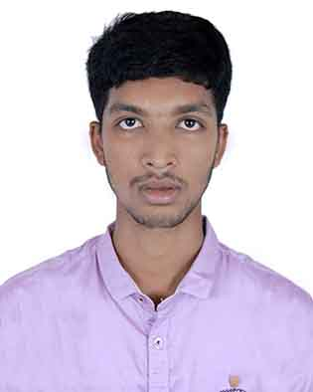

Resume of

MEHEDI HASAN
284, West Nakhalpara,
Tejgaon, Dhaka-1215.
Mob: 01767-330254
E-mail: hmehedi721@gmail.com

Career Objective

- I am interested to work in a dynamic, challenging creative and service oriented organization where I can explore my creative and use my academic and working knowledge and expertise properly.

Academic Certification

- LL.B (Hon’s)
- Institute : Daffodil International University
- University : Daffodil International University
- Department : Law
- Session : 2017-2018
- Semester : 5th Semester (Running)

- Higher Secondary Certificate (H.S.C)
- Institute : Govt. Khulna Model School & College
- Board : Jessore
- Group : Science
- Passing Year : 2017
- Result : GPA- 4.17 (out of 5.00)

- Secondary School Certificate (S.S.C)
- Institute : Kumira M.L. High School
- Board : Jessore
- Group : Science
- Passing Year : 2015
- Result : GPA- 4.50 (out of 5.00)

Computer Skills

- Computer Office Application.
- Internet Browsing & E-mail etc.

Language Proficiency

- English: Good command over reading, writing and speaking.
- Bangla: Excellent command over reading, writing and speaking.

Interests

- Reading Novels, Traveling, Playing and Listening to music & sharing with friends.

Personal details

- Name : Mehedi Hasan
- Father’s Name : Md. Safidul Islam
- Mother’s Name : Rexona Parvin
- Permanent Address : Vill: Amtolardanga, P.O: Patkelghata,
P.S: Patkelghata, Dist: Satkhira.
- Date of Birth : 11-04-2000
- Religion : Islam
- Nationality : Bangladeshi (by birth)
- Marital Status : Unmarried
- Sex : Male
- Height : 5'-10"
- Weight : 49 Kg

Personal Abilities
I am self confident and positive, willing to accept responsibility performing according and able to work in teams as well as individually and capable of maintaining effective communication.

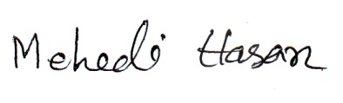
Signature Date:.........................

