RESUME

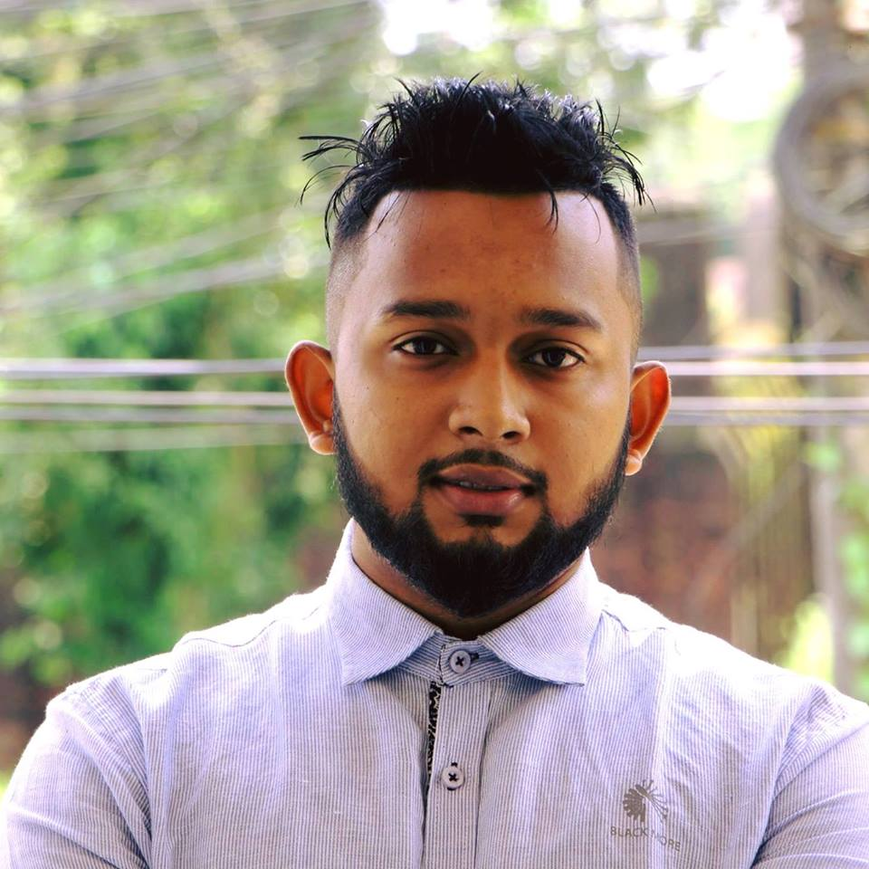

OF
AMDADUL HOQUE MANNA
Mailing Address:
Subhanighat moubon Sylhet.
Contact: 01719233503
E-mail: amdadulhoquemanna@gmail.com

Career Objectives:
I would like to utilize my lively & energetic attitude with great enthusiasm with my administrative & institutional abilities, I would also work to perform administrative task & responsibilities. I would also like to participate in doing constructive programs.
Key Qualifications:
I am Communicative, confident, dedicated, self-motivated, fast learning punctual, strong analytical skill, leadership capability, responsibility taking attitude
Academic Qualification:
Exam Title | Concentration | Institute | Result | Passing Year | Duration
LL.B | Bachelor Of law | Metropolitan University, Sylhet. | CGPA- 3.00out of 4.00 | 2018 | 4 years
Higher Secondary Certificate | Commerce | Madan mohan college | GPA- 1.60 out of 5.00 | 2011 | 2 years
Secondary School Certificate | Humanities | The aided high school | GPA3.44 out of 5.00 | 2009 | 2 years

Personal Details:

Full Name : Amdadul Hoque Manna
Father’s Name : Kutub Uddin
Mother’s Name : Sultana Begum
Sex : male
Date of Birth : 4 march, 1993
Height : 5’ – 4”
Nationality : Bangladeshi (by birth)
Permanent Address : Pathan Tula Jahangir Nogar , Sylhet.
District : Sylhet
Religion : Islam
Marital Status : Single

Extra qualification
Present time I am working at daily shuboprotidin at north jail road as a senir staff reporter from September 2017 to till now.
Past 3 year Child journalist MMC mass line media center a project of unicef
Bangladesh sylhet region.
Scout Leader oroni open scout group, sylhet
Organiged secretary Bangladesh nritto shilpi shongsta, sylhet region,

Refference:
- Name Gazi saiful hasan,
Head Of Department law and justice Metropolition University.

Bilkis akter sumi
Senior journalist gazi Telivisoin, sylhet region
Contract:01712600639

Declaration:
I am certifying that this CV correctly described my biography, education & all other information.

---------------------------------
AMDADUL HOQUE MANNA
Date:

