NibeditaChowdhury
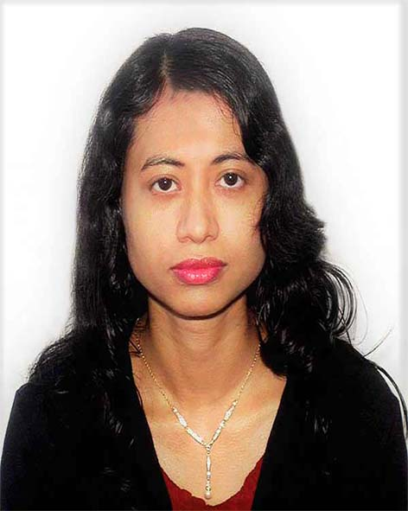
Bahubal 4 No Road, House No 25/2,
Shahaporan, Sylhet,
# 01727173042
#nibeditatinni@gmail.com
EDUCATION
Masters of Information Systems Engineering Management
Harrisburg University (HU) March 2018 – December 2018
Harrisburg , Pennsylvania
- Relevant Courses: Information System Strategic Planning, Business Strategy and Management principles, Enterprise Architecture and Integration, Web-based Software Engineering.

Advance level English Language June 2016- February 2018
ALCC (American Language Communication Center)
- High Advance level Manhattan, New York.
Advance Level English Language Course
Talk Language School April 2015 - November 2015
- Advance Level 8 Davie, Florida
Master of Business Administration​ ​in marketing(One year) September 2013-December 2015
Nova Southeastern University ​(NSU) Fort Lauderdale, Florida
● Relevant Courses:​ Introduction to Marketing, Managerial Marketing, Managing Organizational Behavior, Information Systems management, Business Ethics, Digital Marketing

Bachelor of Business Administration in Marketing ​December 2012
Metropolitan University Sylhet, Bangladesh
● Relevant Courses:​ Introduction to Marketing, Brand Management, Marketing Management, Consumer Behavior, Marketing Research, Advertisement, Distribution Management, Organizational Behavior, International Marketing.

MARKETING EXPERIENCE

Marketing, Sales, Cash and Telemarketing Experience April 2015 – January 2019
Dennys, Afghan kabab and grill , Radha Be Beautiful Florida, NewYork

Graduate Student Assistant (Event Staff) September 2014- March 2015
Nova Southeastern University Fort Lauderdale, Florida
Marketing and sales planning (Summer Internship) July 2014- August 2014
The Smith Company Fort Lauderdale, Florida
● Monitoring and managing sales manager marketing calendar ● Meeting Planning ● Sales CRM updating and management

Marketing Analyst Internship ​ September 2012 – December 2012
National Bank Limited, Chhatak Branch Chhatak, Sunamganj, BangladeshBangladesh
● Analyzed and researched the banking market including competitor practices to gain greater understanding of how to give best customer service in the competitive market
● Communicated a variety of information to customers including banking plans, details regarding their account and ensured that all of their financial needs were being met
● Addressed customer issues including complaints, account accessibility, and financial questions by listening to their individual needs and ensuring that the appropriate resources or referrals were provided
● Handled and managed Financial Transactions including data entry accounting by analyzing the current account, monthly account and fixed deposit account
● Writing of Internship Report which helped to develop communication skills further
● Participated in the Metropolitan University Research Conference
MARKETING PROJECTS
Company Marketing Plan Spring 2014
Introduction to Marketing, NSU
​Fort Lauderdale, Florida
● Collaborated with a team of 5 individuals to develop a marketing plan for “Tesla Model X” to create stronger brand awareness in Florida
● Worked on the “Marketing Mix & Break Even Analysis” aspect of the project, which provided insights on the strengths of the company including the environmental benefits and the shortcomings including the need for stronger promotional material to reach out to potential customers
● Evaluated new technology that may be applicable to the company and determined how such initiatives can affect sales and overall growth

SKILLS Computer:
​Proficient in Microsoft Word, Excel, PowerPoint & Access, Photoshop,

Date: Signature

