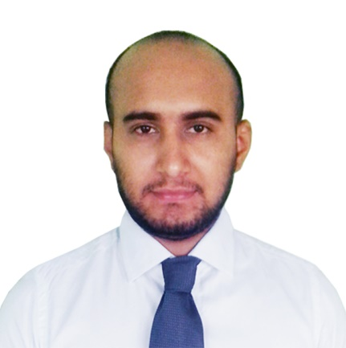
MD: NUR HOSSAIN

Contact Address:
RN Road, Kotwali, Jessore
Mobile: +8801943530238
E-mail: nurhossain009@gmail.com

CARREER OBJECTIVE:

Seeking a position in a progressive company, where my academic knowledge will be utilized fully to improve operations and contribute in organization success and in return I would be benefited self-development and enriched with more skills and experience.

PERSONAL DETAILS:
Father’s name : Md. Hajer Ali Gazi
Mother’s name : Aleya Khatun
Permanent address : Vill:-Goran Baria, Post:-Shimulia, P.S:-Debhata, Dist:- Satkhira.
Date of birth : 18.05.1996
Nationality : Bangladeshi.
Sex : Male.
Marital status : Unmarried.
Religion : Islam(Sunni)
National ID No : 19968712547000445

EDUCATIONAL QUALIFICATION:

Degree | Subject/Group | Board | Year of Passing | Result
Diploma Engineering | Electrical Engineering | BTEB | 2016 | 3.01  (out of 4.00)
S.S.C | Science Studies | JESSORE | 2011 | 4.75  (out of 5.00)

MY SKILL:
- Project Management
- Administrative Support
- Personal / Virtual Assistant
- Google Adwords
- SEO - Search Engine Optimization
- SEM - Search Engine Marketing
- PPC Management
- Technical Support
- Web Research
- Website Design
- Youtube Video Making
- Website Monitoring & Finalization
- Email & Marketing Automation
- SMM - Social Media Marketing (Facebook, Twitter, Linkedin, Google+, Youtube, Etc)

MY TRAITS:
- To work in challenging environment.
- To pursue a carrier that involves decision making & opportunity for self- development.
- To work in a team with creative ideas.
- To do hard work.

LANGUAGE PROFICIENCY:
- Bengali: Fluency in speaking, reading & writing.
- English: Excellent in speaking, reading & writing.

CO-CURRICULAM ACTIVITIES:
- Ex-Secretary of Anti-Smoking & Drug Organization, FnF, JPI.
- Ex-Member of Blood Donation Club, JPI.
- Directly involve with many local programs.

TRAINING:
Name of Training | Name of Institution | Duration
The Industrial attachment training program. | Matlab Karigori & Computer Proshikkon Institute | 12 weeks
Enterprise Challenge Award (2012) (Training for Self Employability) | British Council, Dhaka | 2 Days

REFERENCES:
- Mst. RebekaYeasmin
Chief Instructor
Department of Electrical Engineering,
Jessore Polytechnic Institute, Jessore.
Cell:+8801775-275690

- Dr.Engr.Mohammad Abdulla
Principal
Jessore Polytechnic Institute, Jessore
Cell: +8801535777535

DECLARATION:
I hereby declare that all the above mentioned information is true to best of my knowledge and belief.

Date: …………..……

