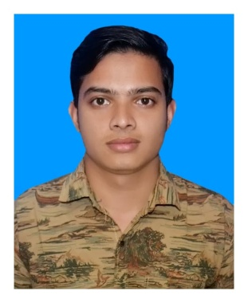
RESUME
OF
MD NURISLAM

Address:
House-31, Road-01/D, Nikunja-02, Khilkhet, Dhaka-1229

Mobile Number :
+88 01744674249

E-Mail:
nurislamnaeem1999@gmail.com

Career Objective:
My career objective is to build my career with air ticket sales & marketing professionals. I would like to take challenging at any position, air ticket Sales & Marketing is a challenging job, what is my choice.

Special Qualification:
# Hard worker, quick learner & ability to assume responsibility.
# Work well under pressure as part of a team.
# Talented in problem solving.
# Having good experience in Microsoft Excel & Word.

Academic Qualification:

- Higher Secondary Certificate (HSC)
Sunflower school & College
Major/Group: Science
CGPA :3.75 Out Of 5.00
Passing Year : 2017

- Secondary School Certificate (SSC)
Hashimpur High School
Major/Group: Science
CGPA: 4.33 Out Of 5.00

Language Proficiency:

Language | Reading | Writing | Speaking
Bangla | High | High | High
English | Medium | Medium | Medium

Personal Details :

Father's Name | : | Md Hobibor Rahman
Mother's Name | : | Most Nur Banu
Date of Birth | : | October 13,1999
Gender | : | Male
Marital Status | : | Unmarried
Nationality | : | Bangladeshi
National Id No. | : | 1954333215
Religion | : | Islam
Permanent Address | : | Village -Hashimpur, Post –Boro Hashimpur, Thana -Chirirbandar, District -Dinajpur.
Current Location | : | Dhaka

Reference (s):

 |  | Reference
Name | : | Saifuzzman Mintu
Organization | : | Saif Air Aviation
Designation | : | Air Ticket & Visa Processing Sales Ceo
Address | : | House#31,Road#01/D,Nijunja#02,Khilkhet,Dhaka
Phone (Off. /Per.) | : | +8801717507267
Relation | : | Professional

Here, I declared that the above information in my CV is correctly described which are true and updated to the best of my knowledge and belief.

Sincerely,


_ _ _ _ _ _ _ _ _ _ _ _ _ _ _ _ _ _ _
Md Nurislam

