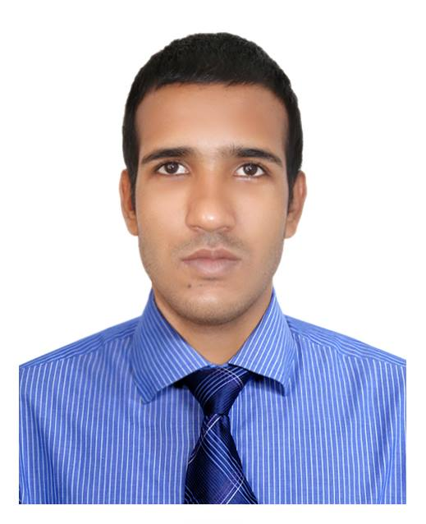
Curriculum Vitae

Personal Information

Name : Md. Nurnabi
Father : Md. Amir Hossain
Mother : Jarina Begum
Present Address : House-34, Road-2, Nikunja-2, Khilkhet, Dhaka-1229.
Permanent Address : Vill- Mahmudpur, Po- Chatutia, PS- Gopalpur, Dist- hTangail.
Date Birth : 11 March 1994
Blood Group : B (+ve)
Religion : Islam
Height : 5̍̍.8̎̎
Marital Status : Unmarried
Nationality : Bangladeshi
Contact Number : +88 01731652738
Email : nurnabihasn145@gmail.com

Career Objective

To work in challenging, environment, achieve skills in respective field and work for the simultaneous progression of organization and myself. I am self motivated, intelligent, diligent and ready to go to the extra leg to achieve the largest. I have set for myself. I am a natural team player and I can lead and be lead as the situation requires. I am an optimist by nature And have a good sense of humor.

Page 1 of 2

Educational Information

Exam | Board | Institute | Group | GPA/  CGPA | Passing Year
S.S.C | Dhaka | Mahmudpur High School | Humanities | 3.63 | 2011
H.S.C | BTEB | Khandakar Asadujjaman Accademy | Computer Office Application | 4.62 | 2013
Hons | National University | Asian University of Bangladesh | B.S.S (Economics) | 3.00 | 2017

Computer Skill
[
- Microsoft Word
- Microsoft Excel
- Microsoft PowerPoint
- Adobe Photoshop
- Internet Browsing

Language Proficiency
[
- Bangla: Excellent listening, Speaking, Reading and Writing.
- English: Excellent listening, Speaking, Reading and Writing.

Working Experience
[
- Granulation Operator ( October 2013-March 2015)
Novartis Pharma
Nishatnagar, Tongi, Gazipur.

- Customer Service Representative (September 2017- February 2018)
Sinha Group
Nikunja-2, Khilkhet, Dhaka

Proclamation

I hereby, declare that information stated here is true to the best of my concern.

Signature and Date
Page 2 of 2

Md. Nurnabi

