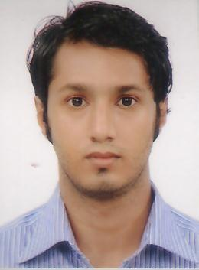
Resume of:

MD. Nurul Islam
Nobarun 52, Shunarpara,
Shibgonj,Sylhet.
Tel: +8801737-81-3355
Email: nurul_islam14@hotmail.com

Career Objective

Intend to work with challenging profession in reputed organization where I can get opportunity to work with honesty and sincerity as well as learn and take greater responsibility.

Academic Qualification

Exam title | Group/Major | Institution | Result | Passing year
S.S.C | Science | Bangladesh International school, Bahrain | GPA: 4.25 | 2005
A Level | (Physics,Chemistry,Maths) | Global institute of science and management, Bahrain | Chem=d  Math=e  Phy=f | 2008
National Diploma (level 3) | Aeronautics | Aeronautical College of Bangladesh | Distinction Discinction Merit  (DDM) | 2011
Higher National Diploma  (level 5) | Aeronautics | Aeronautical College of Bangladesh | Merit | 2014

Skills:

- Higher Diploma in computer science and engineering M.S.Word, Excel, Access,Power Point, Database, Internet and E-mail,Visual basic, and C++ Pro from NATIONAL YOUTH DEVELOPMENT TRAINING CENTER (NYDTC).
- Adobe photoshop,Adobe illsutrator, Adobe Indesign course from New Horizon.
- IELTS score of 7.0 on jan 2009

Language Proficiency

Language | Speaking | Reading | Writing
Bangla | Fluent | Fluent | Good
English | Fluent | Fluent | Good
Hindi | Good | Poor | Poor

Personal Information

- Name: MD.Nurul Islam
- Father Name: Haji Abdul Matin
- Mothers Name: Nargis Akther
- Address: Nobarun 52,Shunarpara,Shibgonj, Sylhet
- Cell No: 01737813355
- E-mail: nurul_islam14@hotmail.com
- Date of Birth: 17th January 1988
- Gender: Male
- Nationality: Bangladeshi
- Religion: Islam (sunni)
- Marital status: Single
- Blood group: B+

Certification:

- I certify that all information stated in this resume is true and complete to the best of my knowledge.

Applicant,
MD. Nurul Islam

