Curriculum Vitae of NUSRAT JAHAN SHIMUL

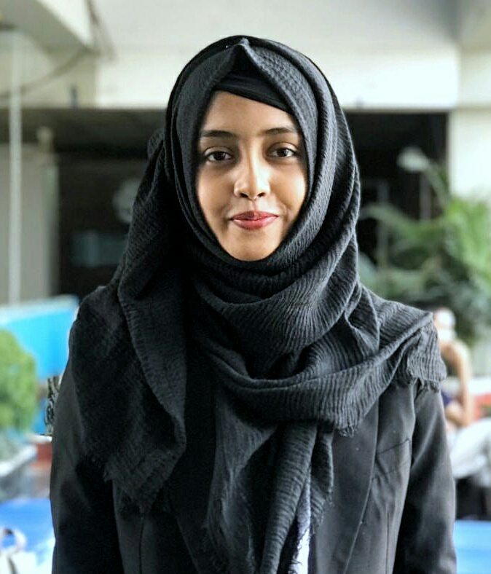
PERSONAL PROFILE
NAME: - Nusrat Jahan Shimul
FATHER’S NAME: - Akter Hossain Arzoo
MOTHER’S NAME: - Shahena Begum Hena
DATE OF BIRTH: - 01/01/1998
NATIONALITY: - Bangladeshi by birth
RELIGION: - Islam
MARITAL STATUS: Unmarried
ADDRESS: - Khan cottage 101/3, Sonar Bangla R/A, East kajal shah, Bagbari road, Sylhet.
EMAIL: - nusratjoya27@gmail.com
PHONE NUMBER: - +8801688816917
+8801798027006

EDUCATIONAL PROFILE
- LL.B. Honors
INSTITUTION – Metropolitan University, Sylhet
PASSING YEAR- 2019(DECEMBER)
CGPA- 3.57(out of 4)
- Higher Secondary Certificate
INSTITUTION – Blue Bird School & College
PASSING YEAR – 2015
DIVISION – Sylhet
GPA – 3.92
- Secondary School Certificate
INSTITUTION – Blue Bird School & College
PASSING YEAR – 2013
DIVISION – Sylhet
GPA – 4.75

EXTRA CURRICULAR AND CO-CURRICULAR ACTIVITIES

TRAINING/WORKSHOP/SEMINAR/COMPETITION/ MEMBERSHIPS TITLE | TOPIC | INSTITUTION/ORGANIZATION | YEAR | DURATION
- Justice for all program | Women participation in legal sectors | USAID | 2016 | One day
- Parliamentary debate competition | Debate | Democracy international | 2019 | One day
- Committee Member of Volunteer For Bangladesh, Sylhet Division | Sustainable Development goals, Underprivileged children | Volunteer For Bangladesh Sylhet Division, (VBD Sylhet) | 2018 | -
- Democracy Watchers; A Youth Initiative | Democracy | Volunteer For Bangladesh | 2017 | One day
- Divisional Debate Championship | Debate | UN Women of Bangladesh & North East University Bangladesh | 2018 | One Day
- Divisional Debate Competition | Debate | Shah Foundation | 2017 | One Day
- Justice for all program | Recent scenario of women on court | USAID | 2017 | One day
- Inter University Debate Competition | Debate | Leadership development Forum | 2018 | Four Days
- Extempore speech competition | World environmental day | Metropolitan University | 2018 | One day
- Member of Jaago Foundation | Quality Education | Jaago Foundation | 2016 | -
- Member of Network For International Law Students(NILS) | International Law Students’ forum | Network For International Law Students(NILS | 2017 | -
- National Conference on Rule of Law & Natural Justice | Rule of Law & Natural Justice | Department of Law & Justice, Metropolitan University | 2019 | One Day
- National Debate Campaign (Sylhet Division) | Debate | Dhaka University Debating society & Shahjalal University Debating Society | 2018 | One Day
- National Debate Competition | Debate | North East University Bangladesh | 2018 | One Day
- Countrywide clean water and sanitation campaign-2018 | Creating Awareness | Jaago Foundation and wateraid | 2018 | Five days
- Seminar and Workshop On ‘Workflow in Research Agenda” | Research | Metropolitan University | 2018 | Three Days
- Intra university debate championship | debate | Metropolitan University | 2019 | Two days
- Extempore speech competition | speech | Metropolitan University | 2019 | One day
- Seminar on sexual harassment | Sexual harassment on digital platform and approaches to social networking sites | Metropolitan University | 2019 | One day
- Workshop on Law Career Development | Career Development on Law | Department of Law & Justice, Metropolitan University | 2018 | One Day
- Workshop On Mooting | Mooting | Department of Law & Justice, Metropolitan University | 2018 | One Day
- Admission fair | Convincing and counseling students to take admission | Metropolitan University | 2019 | Two days
- Admission fair | Convincing and counseling students to take admission | Metropolitan University | 2018 | One day

COMPETENCIES

- Good interpersonal skills, like- public speaking, good communication, leadership and presence of mind.
- Strongly believe in honesty and dignity.
- Quick learner, sincere, self-confident & self-motivated.
- Able to work individually as well as in group.
- Co-operative, innovative & hardworking.

EXPERIENCE

- Working as an Admission Counselor & Admin at Banyan British School, Sylhet from January 7, 2020.

HOBBIES
- Reading books, novels, articles and different types of journals.
- Communicate with different types of people.
- Debating.
- Crafting.
- Travelling.
- Tree plantation.

LANGUAGE SKILS

Bangla – Native language
English – Good proficiency in writing & basic speaking.

REFERRANCES

- SHEIKH ASHRAFUR RAHAMAN
Assistant Professor
Department of Law & Justice
Metropolitan University, Sylhet
EMAIL: srahaman@metrouni.edu.bd
Cell No: 01716007264

- SHER-E-ALAM
Assistant Professor
Department of Law & Justice
Metropolitan University, Sylhet
EMAIL: s.alam@metrouni.edu.bd
Cell No: 01717180324

DECLARATION

I, undersigned, certify that to the best knowledge & belief, these data correctly describe me & my qualities.

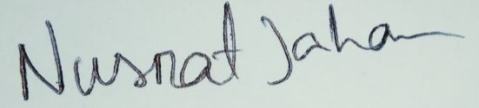

--------------------------------
(Signature)

