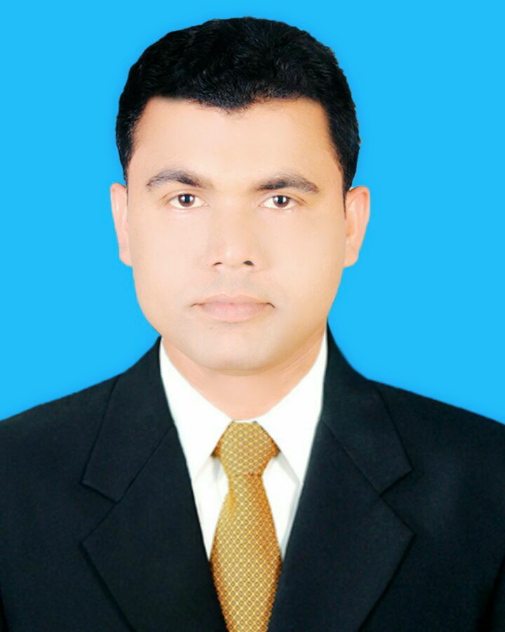
RESUME
OF
MD. OMAR FARUK

108, Monipuripara, 6 No. Gate
Farmgate, Tejgaon, Dhaka-1215
Cell: 01766-467079
Email: omar.mirpur06@gmail.com

Career Objective:

To serve as a technical personnel for the development of the company willing to build up career in a challenging position and to prove myself as a quick learner and highly energetic person to face any challenge in private sector where the contribution will be acknowledged, if would be given an opportunity.

Educational qualifications:

Examination  Passed | Name of  Institution | Year of Passing | CGPA/ Class | Group | Board / University
M.B.A | Kushtia Govt. College | 2015 | 3.09 | Accounting | National University
B.B.A | Kushtia Govt. College | 2013 | 2.77 | Accounting | National University
H.S.C. | Amla Govt. College | 2008 | 3.70 | Science | Jessore
Dakhil | Mirpur Nazmul Ul. Senior Fazil Madrasah | 2006 | 4.92 | Science | Madrasah

Computer Literacy:

- Windows Xp, Windows-7
- Ms-Word, Ms-Excel, Ms-Power Point
- Internet Browsing

Relevant Skills:

- Strong communication and interpersonal skills.
- Able to work under pressure.

Language Capabilities:

Bengali: Mother Tongue.
English : Speaking, Reading and Writing.

Interested:
- Reading Magazines, Story Books, Computer works, and Enjoying Music.
- Working in a team and sharing ideas & views.
- Traveling Historical Places.

Personal Information:

  - Name : Md. Omar Faruk
  - Father’s Name : Md. Delower Hossain
  - Mother’s Name : Akter Banu
  - Date of Birth : 10th December 1991
  - Nationality : Bangladeshi (by birth)
  - Religion : Islam
  - Sex : Male
  - Marital Status : Married
  - Height : 5 Feet 6 Inch
  - Blood Group : O^{+ (ve)}

Address:
Permanent Address :
Vill : Miropur Taltala
Ward : Ward No-6,
Post : Mirpur
P.S : Mirpur
Dist. : Kushtia-7030

Declaration:

I, the undersigned, certify that, to the best of my knowledge and belief this CV correctly describes my qualifications, my experience and me. I understand that any willful misstatement described herein may lead to my disqualification or dismissal, if employed.

Reference

1. Md. Ashiqur Rahman
Manager
Agrani Bank Ltd.
Rajshahi Branch, Rajshahi
Mobile : 01719550230
E-mail:farukjoarder@gmail.com

2. Md. Moslem Uddin
Associate Professor
Kushtia Govt. College, Kushita
Mobile No. 01813812071
E-mail: omar.mirpur06@gmail.com

Signature:

Md. Omar Faruk
Date:

