Curriculum Vitae
Of
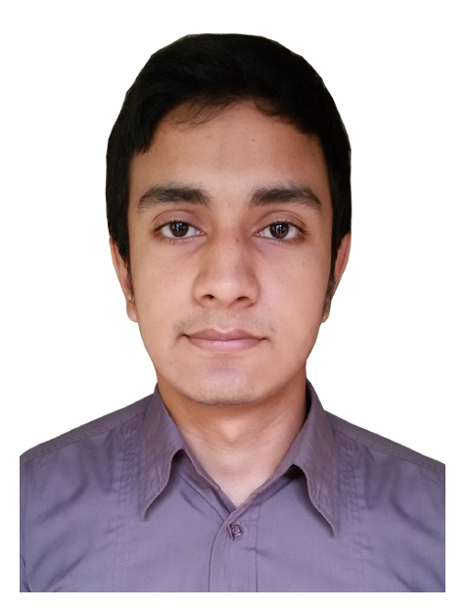

OMIT HASAN
Cell NO- +8801726924822

Career Objective
To face challenges using knowledge, perception and innovation to pursue long-term successful career in dynamic and professional environment of any reputable organization through my aptitude, hard work, dedication and determination.

Personal Profile
Name : OMIT HASAN
Father’s Name : Hussen Ahmed
Mother’s Name : Lipi Begum
Permanent Address : Vill: Gollashangon
P.O. Gollashangon-3171, P.S. Barlekha, Dist.
Moulvibazar.
Present Address : Shibgonj, Sylhet.
Date of Birth : November 04, 1998
NID No. : 19985811463000234
Religion : Islam
Sex : Male
Nationality : Bangladeshi by birth
Marital Status : Single
Hobby : Travelling, Browsing Internet
Cell : +8801726924822
Email : omit.hasan269@gmail.com

Educational Experience
Degree Achieved : H.S.C
Result : Latter Grade A (GPA 4.50 out of 5.00)
Year : 2017
Group : Science
Board : Sylhet

Degree Achieved : S.S.C
Result : Latter Grade A (GPA 4.75 out of 5.0)
Year : 2014
Group : Science
Board : Sylhet
Computer Experience

- MS Office Package Program (MS Word, MS Excel, MS Power point etc.)
- Internet Browsing
Communication Skill
- Fairly fluent in reading, Writing, listening & speaking in English

Date: Signature

